**Table of Contents**

1. **Introduction to Snort**
   * 1.1 What is Snort?
   * 1.2 History and Development
   * 1.3 Importance in Cybersecurity
2. **Installation and Setup**
   * 2.1 Installing Snort on Linux
   * 2.2 Installing Snort on Windows
   * 2.3 Dependencies and Prerequisites
   * 2.4 Verifying Installation
   * 2.5 Directory Structure and Configuration Files
3. **Architecture of Snort**
   * 3.1 Overview of Snort Components
   * 3.2 Packet Decoder
   * 3.3 Preprocessors
   * 3.4 Detection Engine
   * 3.5 Logging and Alerting System
   * 3.6 Output Modules
4. **Modes of Operation**
   * 4.1 Sniffer Mode
   * 4.2 Packet Logger Mode
   * 4.3 Network Intrusion Detection Mode (NIDS)
   * 4.4 Inline Mode (IPS)
5. **Snort Rules**
   * 5.1 Rule Structure
   * 5.2 Rule Header Components
   * 5.3 Rule Options and Keywords
   * 5.4 Example Snort Rules Explained
   * 5.5 Writing Custom Rules
6. **Working of Snort**
   * 6.1 How Snort Captures and Analyzes Packets
   * 6.2 Detection Workflow
   * 6.3 Rule Processing and Alert Generation
7. **Rule Management and Optimization**
   * 7.1 Community and Registered Rule Sets
   * 7.2 Using PulledPork for Rule Updates
   * 7.3 Rule Prioritization and Performance Tuning
   * 7.4 Signature vs. Anomaly-Based Detection
8. **Integration with Other Security Tools**
   * 8.1 Snort with SIEM (Splunk, ELK Stack)
   * 8.2 Snort with Security Onion
   * 8.3 Snort with Firewalls and IPS Systems
   * 8.4 Logging with Syslog/MySQL
9. **Case Study: Snort in Action**
   * 9.1 Detecting Port Scans and DoS Attacks
   * 9.2 Malware Traffic Detection
   * 9.3 Example Enterprise Deployment
10. **Advantages and Limitations of Snort**
    * 10.1 Advantages (Open Source, Flexible, Real-Time Detection)
    * 10.2 Limitations (Performance, Encrypted Traffic, False Positives)
11. **Comparison with Other NIDS/NIPS Tools**
    * 11.1 Snort vs Suricata
    * 11.2 Snort vs Zeek
12. **Conclusion and Future Scope**
    * 12.1 The Evolution to Snort 3.x
    * 12.2 Role of Snort in Modern SOC Pipelines
13. **References**
    * Cisco Talos Documentation
    * Snort Official Guides
    * Security Blogs and Research Papers

**1. Introduction to Snort**

**1.1 What is Snort?**

Snort is an **open-source Network Intrusion Detection and Prevention System (NIDS/NIPS)** developed by **Martin Roesch** in 1998 and now maintained by **Cisco Talos**.  
It is capable of analyzing **real-time network traffic**, detecting **malicious activity**, and either **alerting administrators** (IDS mode) or **blocking suspicious packets** (IPS mode).

In simpler terms — **Snort acts as a digital security guard for your network**. It monitors every packet that enters or leaves the system and checks if it matches known malicious patterns defined in its **rule sets**.

**Snort can:**

* Monitor network traffic in real-time.
* Match packets against thousands of predefined rules or custom signatures.
* Generate alerts for suspicious or malicious activity.
* Prevent intrusions by dropping packets (when in IPS mode).
* Log network traffic for forensic or compliance purposes.

**Snort operates at the packet level**, meaning it inspects headers, payloads, and even protocol anomalies to determine potential threats.

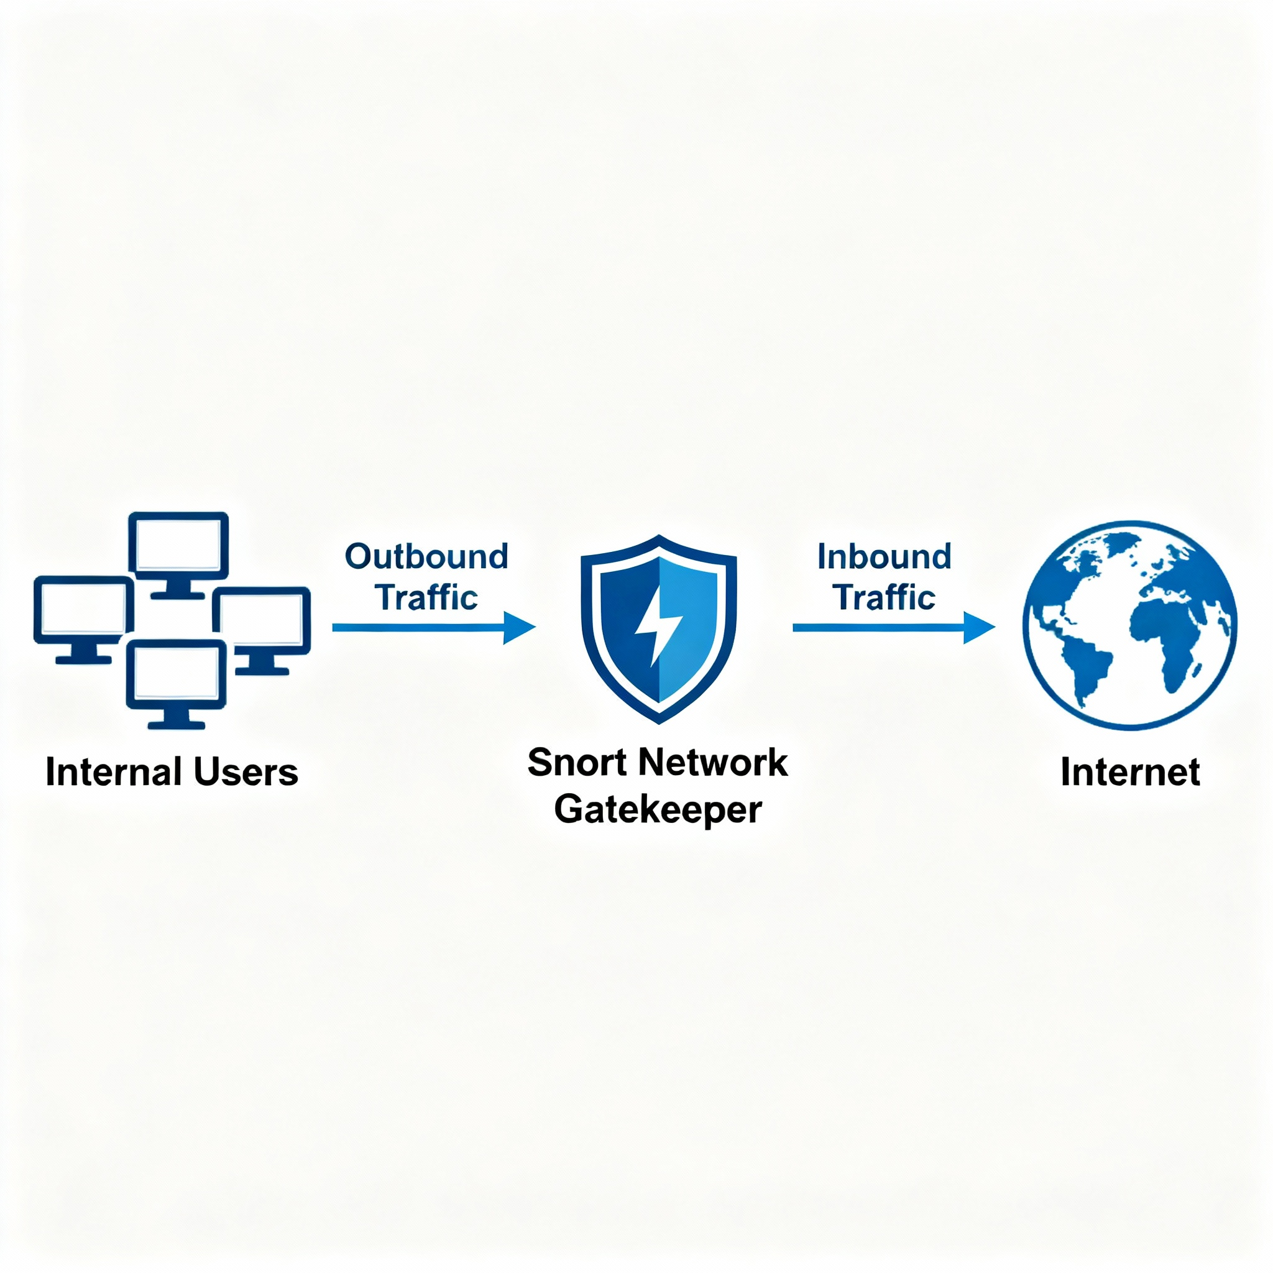

**1.2 History and Development**

Snort has evolved significantly since its initial release, transforming from a basic packet sniffer into one of the most robust and widely used intrusion detection systems in the world.

**Timeline of Snort’s Evolution:**

* **1998:** Martin Roesch released Snort as a lightweight packet sniffer and simple intrusion detection tool.
* **2001:** Snort introduced a rule-based detection mechanism, which revolutionized open-source intrusion detection.
* **2003:** Snort became the foundation for **Sourcefire**, a commercial cybersecurity company founded by Roesch.
* **2013:** **Cisco acquired Sourcefire**, integrating Snort into its enterprise-grade security products such as **Cisco Firepower** and **Secure Firewall**.
* **2020:** Release of **Snort 3**, rewritten in **C++** for improved **modularity**, **multi-threading**, and **performance scalability**.
* **Present:** Snort remains one of the most deployed IDS/IPS engines globally, powering both open-source and enterprise-grade solutions.

**Key Improvements in Snort 3:**

* Modular architecture for flexible component addition.
* Lua-based configuration for easier scripting.
* Better protocol handling (HTTP/2, TLS 1.3).
* Performance boost through multithreaded packet processing.
* Dynamic plugin support for extending detection logic.

Snort’s consistent innovation and strong community support make it an industry standard for network defense.

**1.3 Importance in Cybersecurity**

In today’s cybersecurity landscape, **Snort is a cornerstone for network-based threat detection**. It is widely deployed in **Security Operations Centers (SOCs)**, **universities**, **enterprises**, and **government agencies**.

**Why Snort Matters:**

* **Real-time Intrusion Detection:** Detects and alerts on network attacks such as port scans, malware downloads, or data exfiltration.
* **Intrusion Prevention:** Can actively block or drop malicious packets when configured as an IPS.
* **Customizable Rule Engine:** Security analysts can write rules tailored to specific threats, enabling precise detection.
* **Open Source & Extensible:** Community contributions and Cisco Talos updates ensure up-to-date detection of emerging threats.
* **Integration Capability:** Works seamlessly with **SIEM systems** (Splunk, ELK Stack), **firewalls**, and **forensic analysis tools** (Wireshark, Security Onion).

**Practical Use Cases:**

* Detecting **port scans** and **brute-force attempts**.
* Identifying **malware C2 communications**.
* Monitoring **file transfers** for sensitive data leaks.
* Detecting **SQL injection**, **XSS**, or other web-based exploits.
* Forming a part of **Security Onion**, **SOC pipelines**, or **Network Forensics** workflows.

**Example in Enterprise Setup:**  
A typical deployment may place Snort at the **network perimeter** or **DMZ**, where it analyzes mirrored traffic via SPAN/TAP ports. When integrated with a SIEM, it provides centralized visibility of all network-based threats.

1. **Installation and Setup**

Setting up **Snort** correctly is a crucial step toward deploying it as an effective **Intrusion Detection or Prevention System**.  
This section provides a complete guide to installing Snort on both **Linux** and **Windows**, along with details about configurations, dependencies, and initial setup.

**2.1 Installing Snort on Linux**

**Linux provides the most stable and flexible environment for running Snort, particularly on Ubuntu or Debian-based distributions.**

**Step 1: Update and Prepare the System**

**Before installing Snort, make sure your system is up to date:**

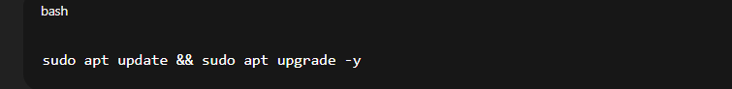

**Step 2: Install Snort**

**You can either install Snort directly from the repository or build it from source.**

**Option 1 – Install via APT:**

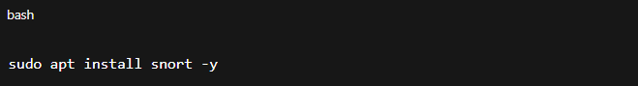

**Option 2 – Install from Source:**

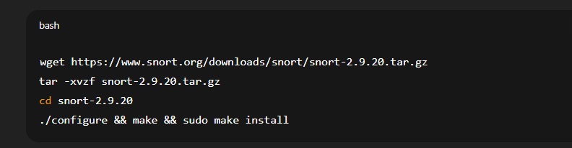

**Step 3: Configure Snort Network Variables**

**Edit the main configuration file:**

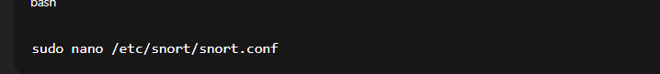

**Set your network:**

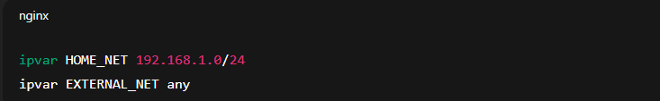

**Step 4: Test the Installation**

**Run a simple command to verify Snort is installed correctly:**

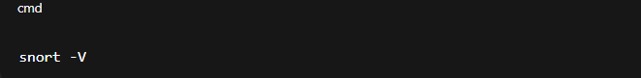

**You should see Snort’s version and build details.**

**Step 5: Run Snort in Different Modes**

* **Sniffer Mode:**
* **sudo snort -v**

**Displays packets in real-time.**

* **Packet Logger Mode:**
* **sudo snort -dev -l /var/log/snort**

**Logs packets for later analysis.**

* **IDS/IPS Mode:**
* **sudo snort -A console -c /etc/snort/snort.conf -i eth0**

**Monitors and alerts based on rule matches.**

**2.2 Installing Snort on Windows**

**While Linux is preferred, Snort can also be installed on Windows systems for testing, learning, or small-scale deployments.**

**Step 1: Download and Prerequisites**

1. **Download the Snort Windows installer from the official** [**Snort website**](https://www.snort.org/downloads)**.**
2. **Install WinPcap or Npcap, which allows packet capturing on Windows.**
3. **Ensure you have Microsoft Visual C++ Redistributables installed.**

**Step 2: Installation**

1. **Run the Snort installer and follow the setup wizard.**
2. **Choose an installation directory (e.g., C:\Snort).**
3. **Verify that Snort binaries (snort.exe) are added to your PATH environment variable.**

**Step 3: Configure Snort**

**Inside the C:\Snort\etc directory, edit snort.conf:**

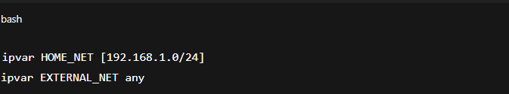

**Step 4: Test Snort**

**Open Command Prompt (Admin) and run:**



**If successful, it will display the Snort version and copyright.**

**Step 5: Run Snort in Detection Mode**

**Example command:**

**snort -A console -c C:\Snort\etc\snort.conf -l C:\Snort\log -i 1**

**This command monitors network interface 1, logs alerts to the specified directory, and outputs results to the console.**

**Step 6: Log and Rule Setup**

* **Default rules are located in:  
  C:\Snort\rules\**
* **Alerts are stored in:  
  C:\Snort\log\alert.ids**

**2.3 Post-Installation Configuration**

**After installation, perform the following configuration tasks to ensure Snort functions effectively:**

1. **Update Rule Sets**
   * **Download the latest community rules:**

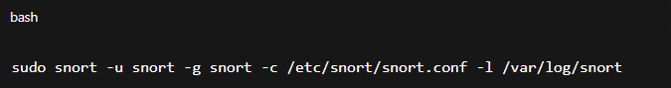

1. **Configure Logging**
   * **Define output plugins (e.g., unified2, syslog, database).**

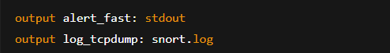

1. **Enable Preprocessors**
   * **Activate preprocessors like http_inspect, frag3, and stream5 in snort.conf to handle protocol normalization.**
2. **Set Snort as a Service (Linux)**
   * **Create a systemd service for automatic startup:**
   * **sudo systemctl enable snort**
   * **sudo systemctl start snort**
3. **Validate Configuration**

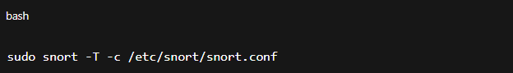

**If the configuration passes, Snort is ready to operate**



**3. Architecture of Snort**

**3.1 Overview of Snort Architecture**

**Snort’s architecture is modular, meaning it is divided into several interconnected components, each responsible for a specific task in packet analysis and detection.**

**At a high level, Snort works as a pipeline:  
Packet Capture → Preprocessing → Detection → Logging/Alerting → Output.**

**Each step progressively refines and analyzes network traffic before deciding whether an alert should be generated.**

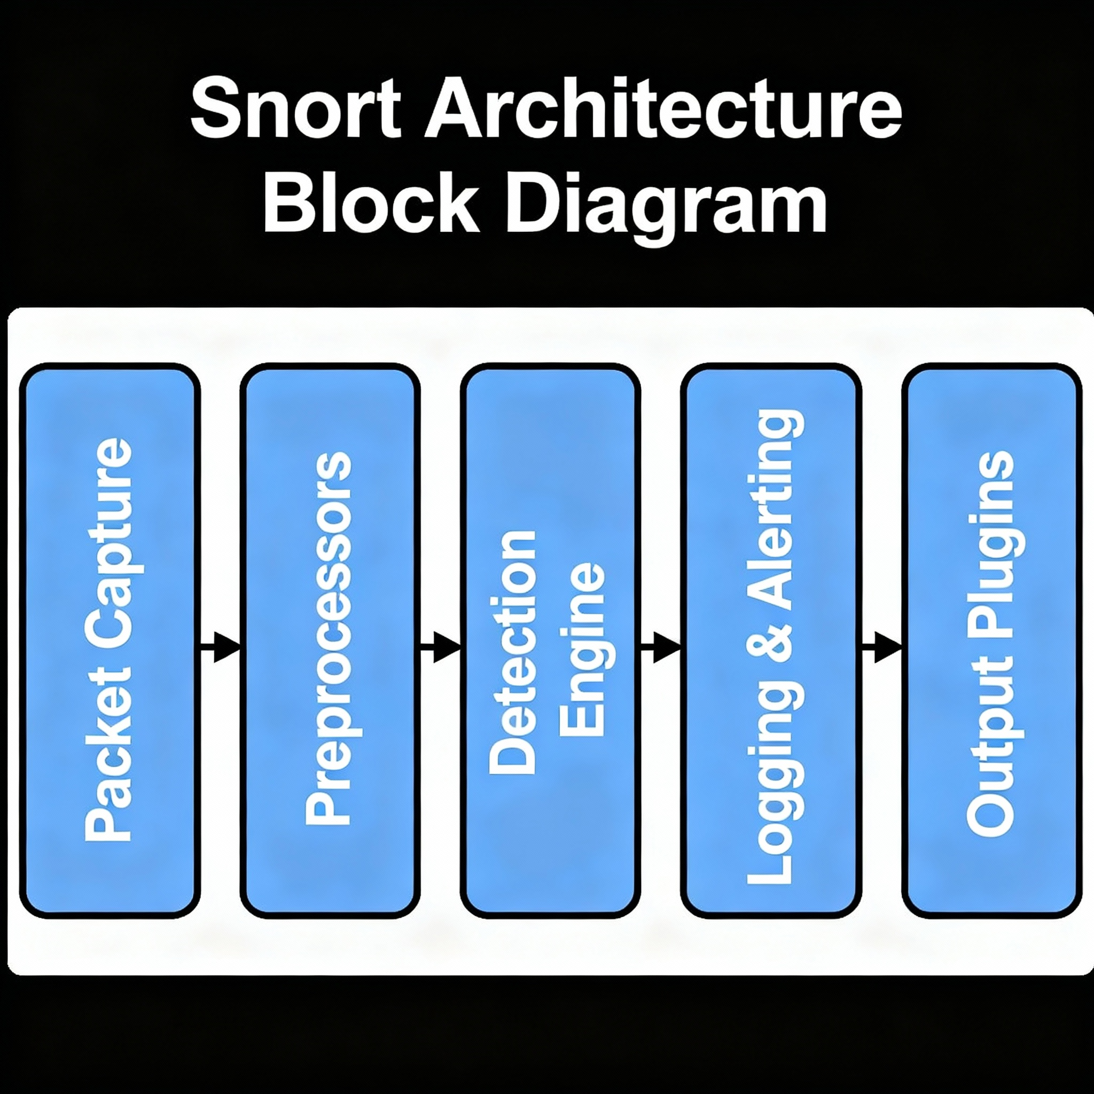

**3.2 Key Components of Snort Architecture**

**1. Packet Decoder**

* **The Packet Decoder captures raw packets from the network interface.**
* **It uses libpcap (Linux) or Npcap (Windows) to sniff network traffic.**
* **The decoder checks for malformed packets and standardizes them into a uniform internal structure.**

**Functions:**

* **Converts Ethernet frames into IP/TCP/UDP packets.**
* **Removes unnecessary headers.**
* **Ensures packets are ready for analysis by preprocessors.**

**2. Preprocessors**

**Preprocessors act as mini-modules that modify or analyze packets before the detection engine checks them.  
They help normalize, decode, or reassemble data for deeper inspection.**

**Common Preprocessors:**

| **Preprocessor** | **Function** |
| --- | --- |
| **Frag3** | **Reassembles fragmented IP packets** |
| **Stream5** | **Tracks TCP sessions and state** |
| **HTTP Inspect** | **Normalizes HTTP headers and content** |
| **RPC Decode** | **Analyzes Remote Procedure Call traffic** |
| **SMTP / POP3 / IMAP Preprocessors** | **Inspects email protocols** |
| **ARP Spoof** | **Detects ARP-based attacks** |

**Example:  
If an attacker sends fragmented packets to bypass detection, the Frag3 preprocessor reassembles them before analysis, ensuring Snort sees the complete payload.**

**3. Detection Engine**

**This is the heart of Snort.  
The Detection Engine applies Snort rules to identify suspicious or malicious traffic patterns.**

**Key Functions:**

* **Compares packet data against rule conditions.**
* **Uses pattern matching algorithms (like Aho-Corasick).**
* **Determines if the packet matches any known signature.**

**Types of Detection:**

* **Content-based: Looks for specific strings (e.g., “cmd.exe”).**
* **Header-based: Matches IP addresses, ports, or protocols.**
* **Anomaly-based: Detects deviations from normal traffic patterns.**

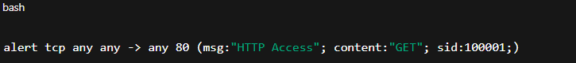

**This rule triggers an alert whenever an HTTP GET request is observed.**

**Performance Note:  
Modern Snort engines use multi-threaded rule matching for faster detection, especially in Snort 3.**

**4. Logging and Alerting System**

**When a packet matches a rule, Snort generates an alert or log entry depending on the rule action.**

**Types of Outputs:**

* **Alert: Sent to /var/log/snort/alert or a database.**
* **Log: Detailed packet information stored for forensic analysis.**
* **Unified2 / JSON Output: For integration with SIEM or Security Onion.**

**Alert Example:**

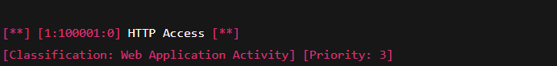

**Actions in Rules:**

| **Action** | **Description** |
| --- | --- |
| **alert** | **Generate an alert and log packet** |
| **log** | **Log packet data only** |
| **pass** | **Ignore matching packets** |
| **drop** | **Block packet (IPS mode)** |
| **reject** | **Block and send TCP RST/ICMP error** |

**5. Output Plugins**

**Output plugins decide how and where alerts/logs are sent.  
These can be configured in snort.conf.**

**Common Output Methods:**

* **Unified2: Standard binary log format for SIEM integration.**
* **Syslog: Sends alerts to system logs.**
* **Database: MySQL/PostgreSQL for structured storage.**
* **JSON / CSV: For modern logging pipelines.**

**6. Rule Database**

**Snort maintains a rule database that defines what constitutes malicious traffic.**

**Rules are divided into categories such as:**

* **local.rules – Custom rules created by users.**
* **community.rules – Publicly shared rules from the community.**
* **emerging-threats.rules – Updated signatures for latest attacks.**

**The rules are stored typically in /etc/snort/rules/.**

**7. Packet Logging System**

**All packets that match rule conditions (or all traffic if configured) can be saved for later inspection.**

**Log Formats:**

* **PCAP – Full packet capture.**
* **Fast log – Minimal log entry for quick review.**
* **Alert log – High-level summary of alerts.**

**Snort logs are essential for forensic analysis and can be reviewed using tools like:**

* **Wireshark**
* **Snorby**
* **BASE (Basic Analysis and Security Engine)**

**8. Performance and Scalability Features**

**Modern Snort versions include enhancements such as:**

* **Multithreading support for parallel packet processing.**
* **Rule grouping and optimization for faster lookups.**
* **DAQ (Data Acquisition Library) abstraction layer, allowing Snort to operate with various network interfaces or PCAP files.**

**These ensure Snort can handle high-throughput enterprise environments efficiently.**

**3.3 Workflow Summary**

**Here’s a summarized view of how Snort processes data end-to-end:**

1. **Packet Capture: Snort collects raw traffic using libpcap/Npcap.**
2. **Decoding: Packet headers are decoded for analysis.**
3. **Preprocessing: Data normalized, fragmented packets reassembled.**
4. **Detection Engine: Packets matched against rule database.**
5. **Logging/Alerting: Alerts generated for matches.**
6. **Output Plugins: Logs exported to files, databases, or SIEM.**

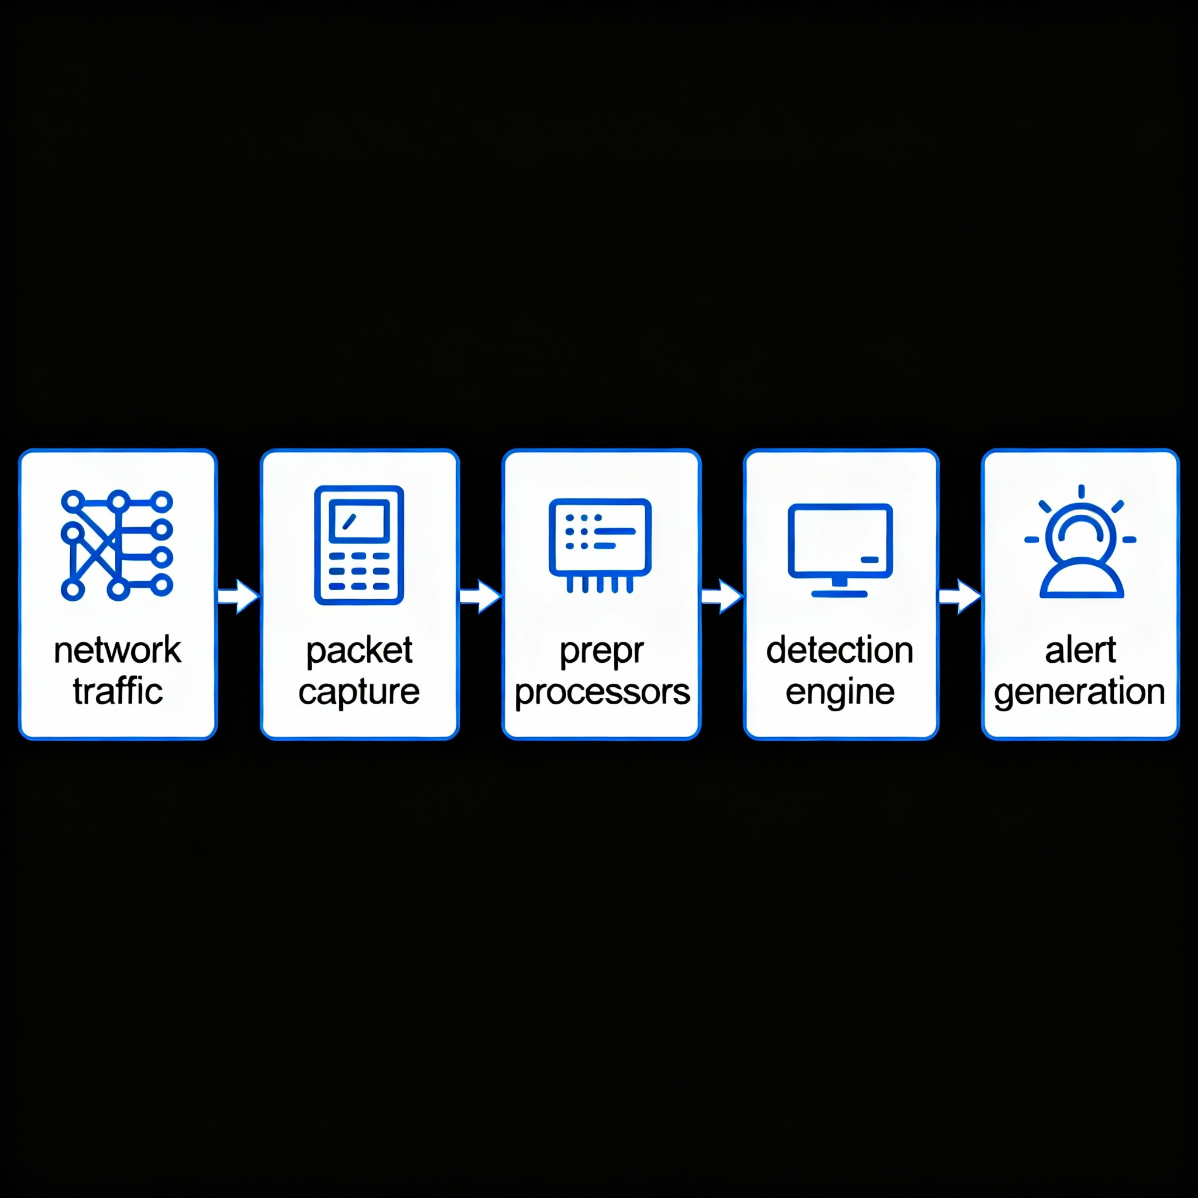

**4. Modes of Operation in Snort**

**Snort can operate in multiple modes, each serving a unique purpose.  
These modes allow Snort to act as a sniffer, packet logger, or a full intrusion detection/prevention system (IDS/IPS) depending on the configuration.**

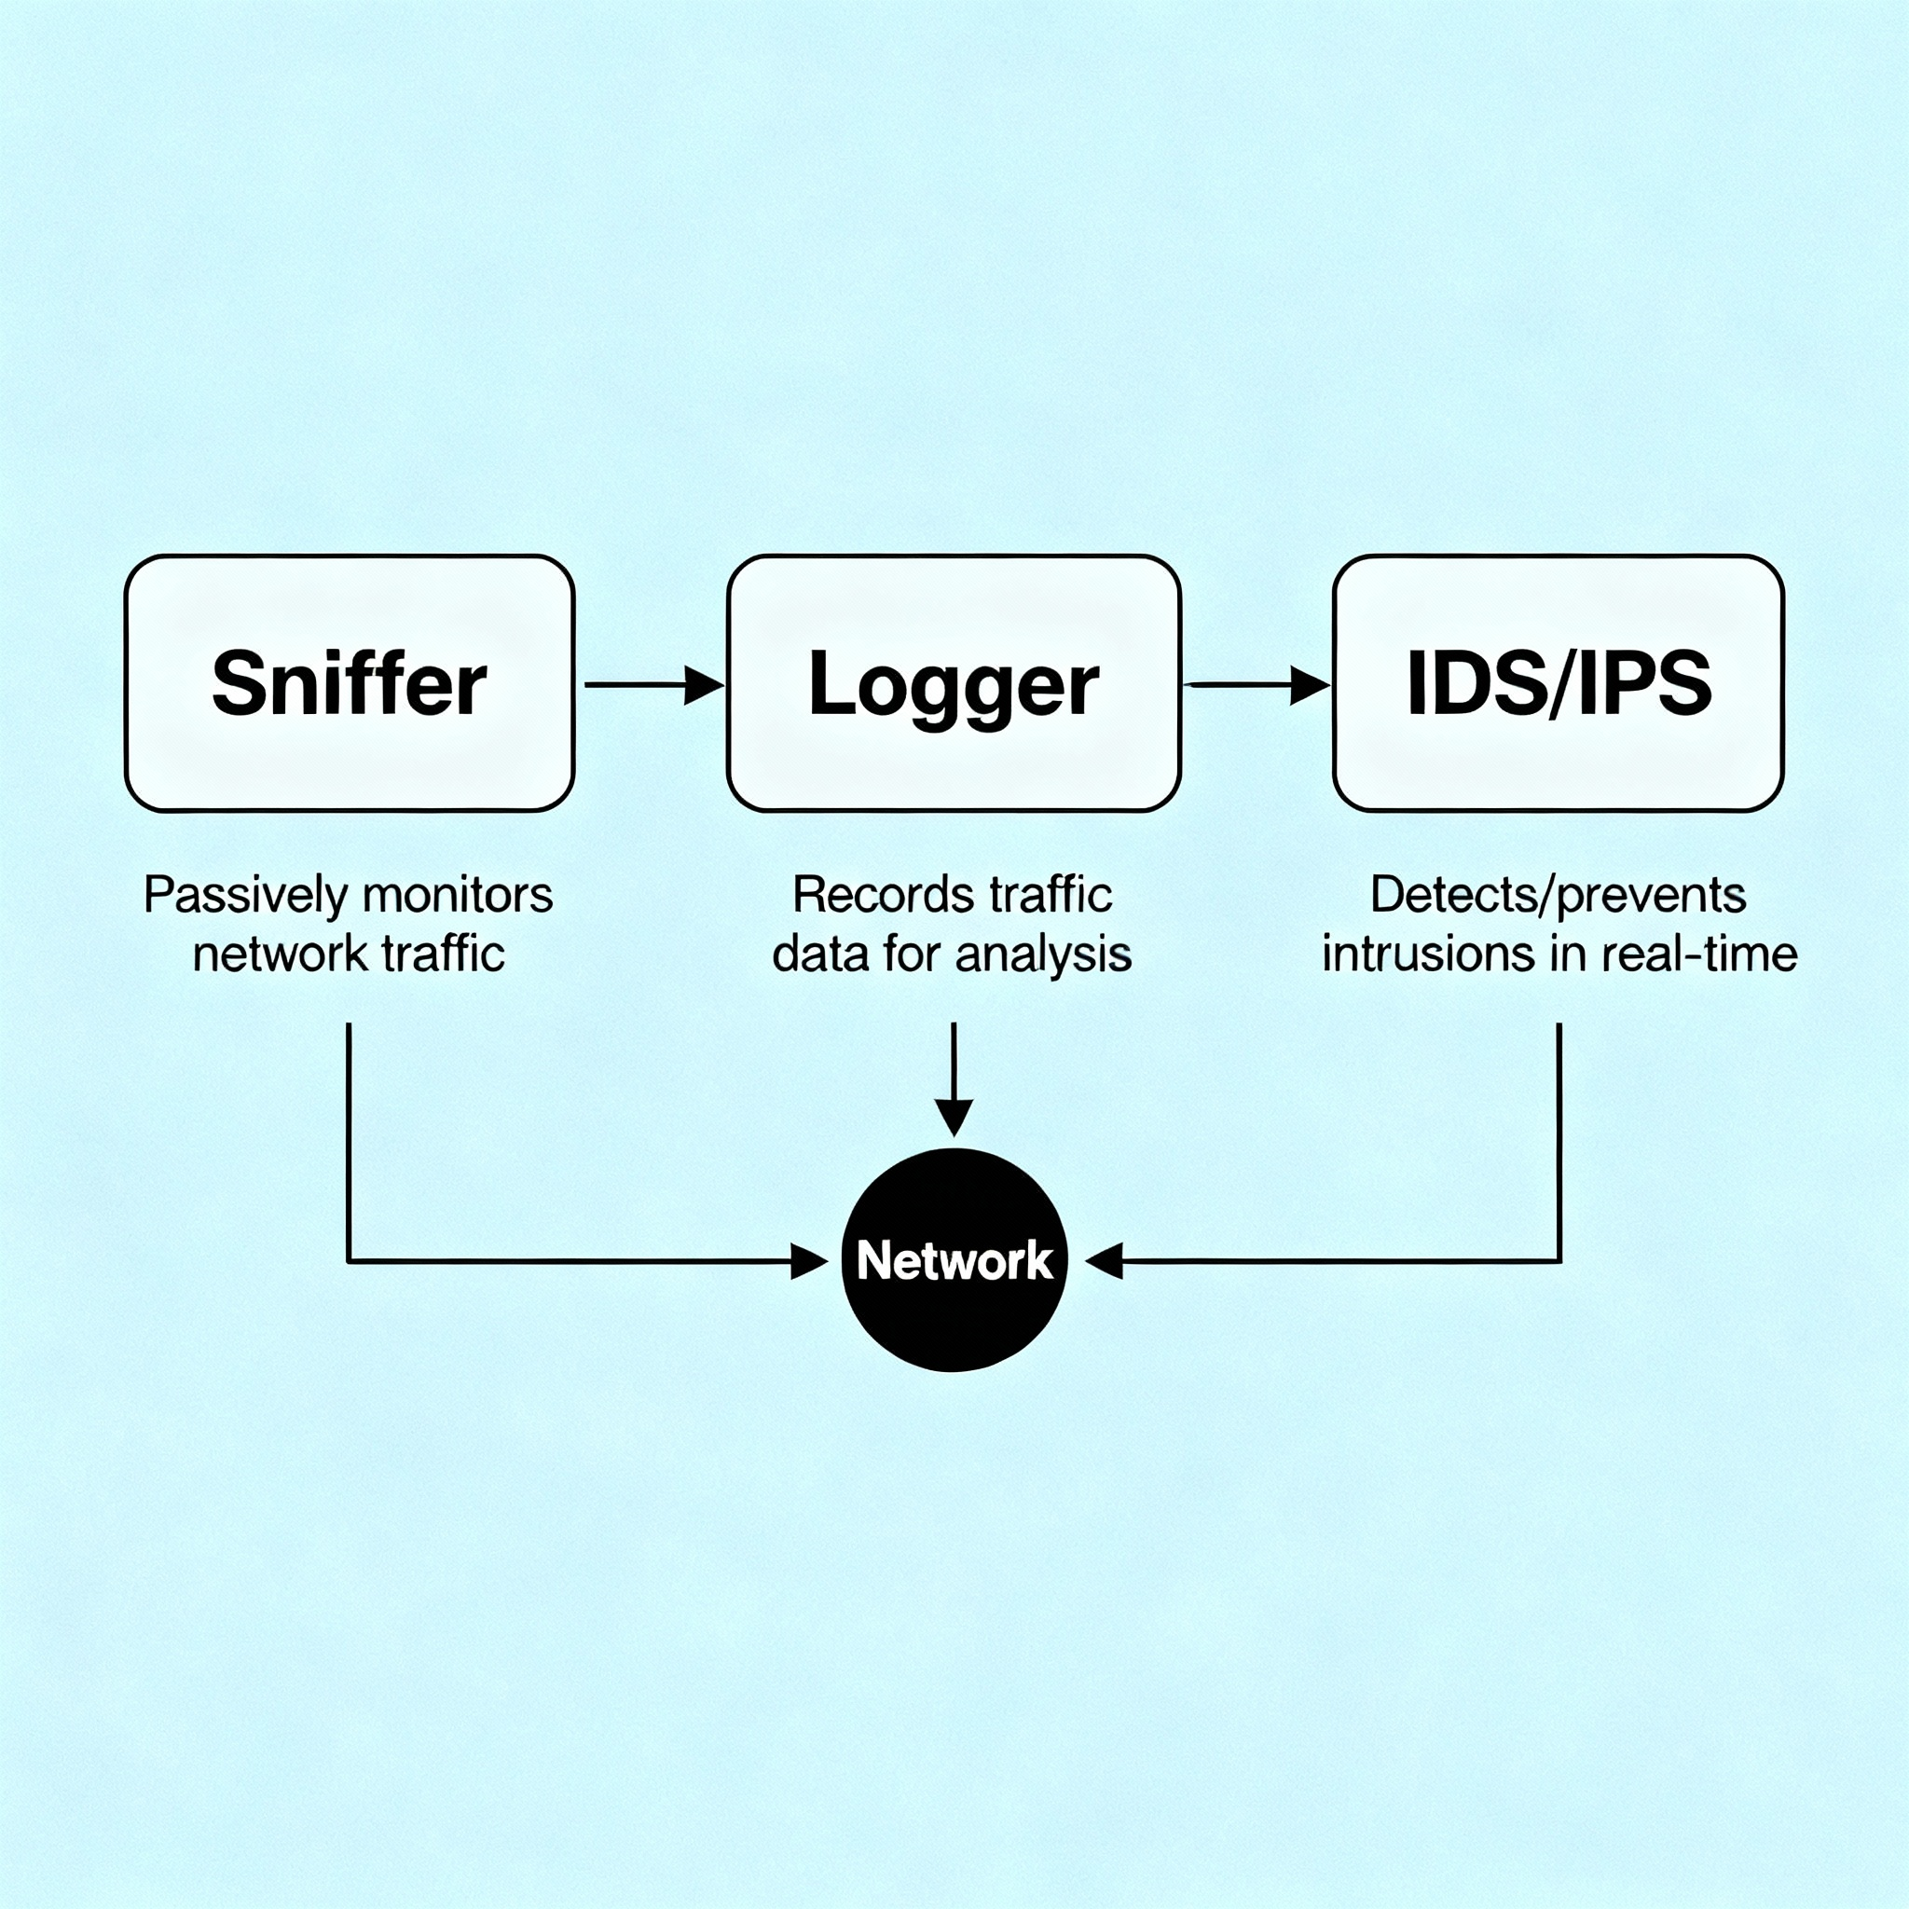

**4.1 Sniffer Mode**

**In Sniffer Mode, Snort simply captures and displays packet headers and payloads in real-time — similar to tcpdump.**

**Command: **

**Options:**

* **-v : Displays packet headers.**
* **-vd : Displays packet headers + data.**
* **-vde : Displays headers + data + link layer headers.**

**Use Case:  
Used for network troubleshooting and verifying whether traffic is reaching the interface correctly.**

**4.2 Packet Logger Mode**

**In Packet Logger Mode, Snort captures and stores traffic data to a file or directory for later analysis.**

**Command:**

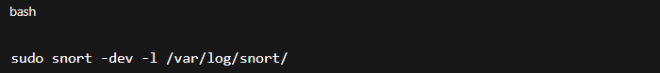

**Here:**

* **-d : Dumps packet payloads.**
* **-e : Displays link-layer headers.**
* **-v : Verbose output.**
* **-l : Specifies logging directory.**

**Use Case:  
Ideal for forensics or long-term network behavior analysis.**

**Logs can be examined later using Wireshark or Snorby.**

**4.3 Network Intrusion Detection System (NIDS) Mode**

**In IDS mode, Snort analyzes packets in real-time and matches them against rule sets.**

**Command:**



* **-A console : Displays alerts on console.**
* **-q : Quiet mode.**
* **-c : Specifies configuration file.**
* **-i : Network interface to monitor.**

**Function:  
Compares packets to rule signatures and triggers alerts when suspicious activity is detected.**

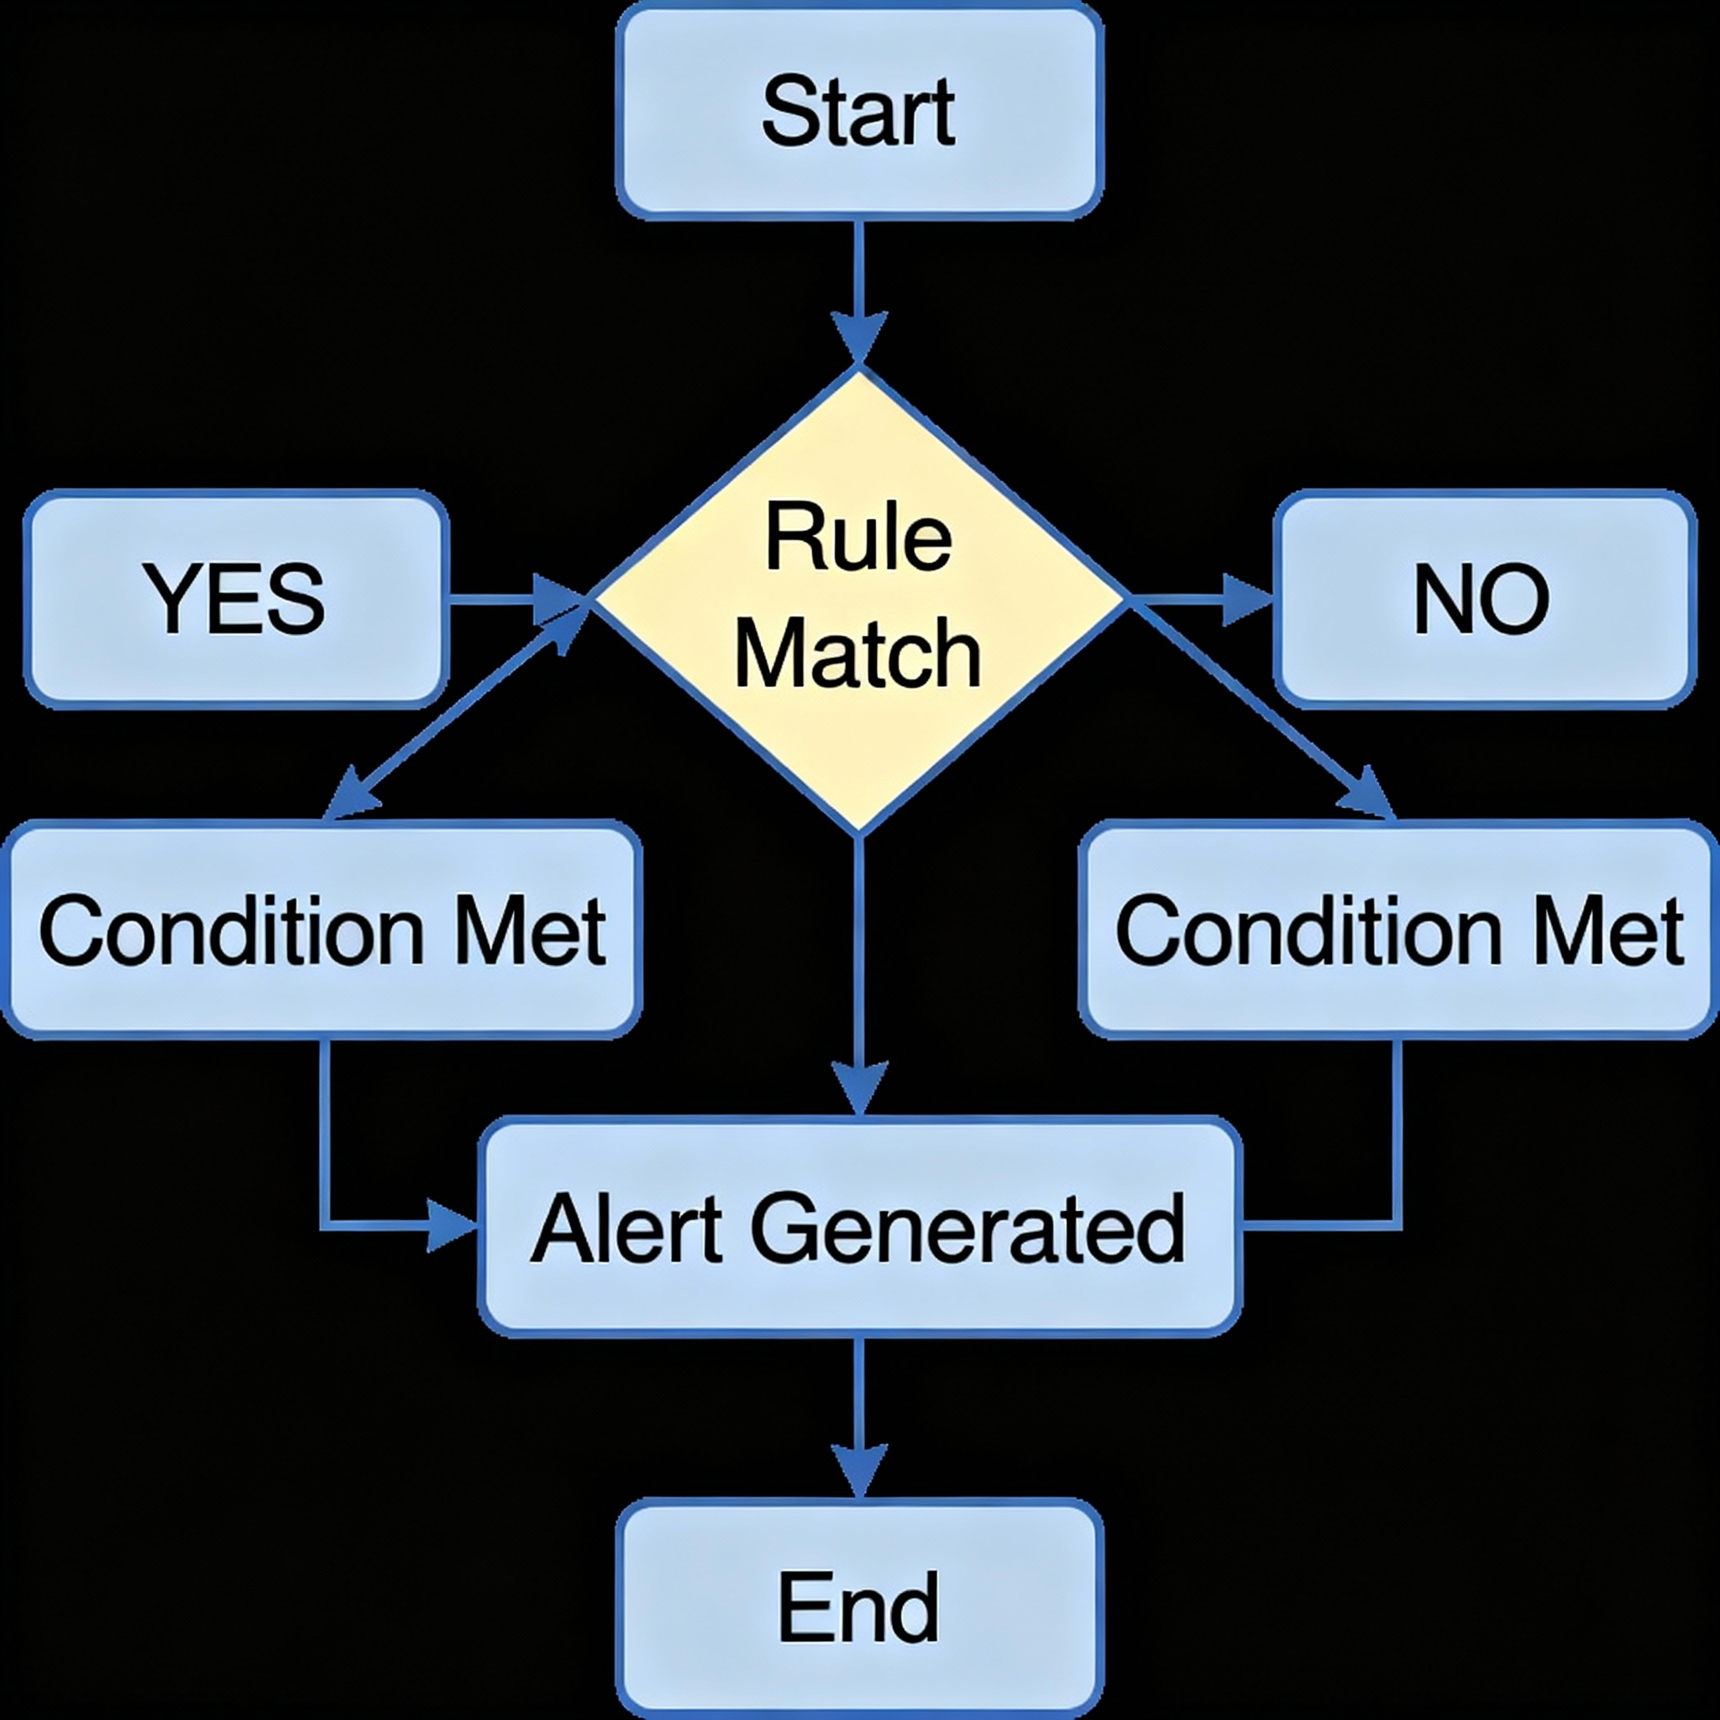

**4.4 Intrusion Prevention System (IPS) Mode**

**In IPS mode, Snort not only detects but also blocks malicious traffic in real-time.**

**It requires inline mode, often implemented with afpacket or nfqueue.**

**Command Example:**

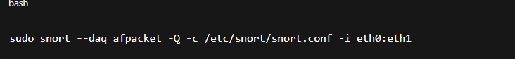**Here:**

* **-Q : Enables inline (IPS) mode.**
* **eth0:eth1 : Bridges incoming and outgoing interfaces.**

**Use Case:  
Used in active defense systems, such as firewalls or SOC environments.**



**Intrusion Detection System (IDS)**

IDS is a passive monitoring solution for detecting possible malicious activities/patterns, abnormal incidents, and policy violations. It generates alerts for each suspicious event.

There are two main types of IDS systems:

* **Network Intrusion Detection System (NIDS)**: NIDS monitors the traffic flow from various areas of the network. The aim is to investigate the traffic on the entire subnet. If a signature is identified, an alert is created.
* **Host-based Intrusion Detection System (HIDS)**: HIDS monitors the traffic flow from a single endpoint device. Its aim is to investigate the traffic on that device. If a signature is identified, an alert is created.

**Intrusion Prevention System (IPS)**

IPS is an active protecting solution for preventing possible malicious activities/patterns, abnormal incidents, and policy violations. It is responsible for stopping/preventing/terminating the suspicious event as soon as it is detected.

 There are four main types of IPS systems;

* **Network Intrusion Prevention System (NIPS)**: NIPS monitors the traffic flow from various areas of the network. The aim is to protect the traffic on the entire subnet. If a signature is identified, the connection is terminated.
* **Behaviour-based Intrusion Prevention System (Network Behaviour Analysis - NBA)**:Behaviour-based systems monitor the traffic flow from various areas of the network. The aim is to protect the traffic on the entire subnet. If an anomaly is identified, the connection is terminated.

The Network Behaviour Analysis System works similar to NIPS. The difference between NIPS and Behaviour-based systems is that behaviour-based systems require a training period (also known as "baselining") to learn the normal traffic and differentiate the malicious traffic and threats. This model provides more efficient results against new and unknown threats.

The system is trained to know the "normal" to detect the "abnormal." The training period is crucial to avoid false positives. If there is a security breach during the training period, the results will be highly problematic. Another critical point is to ensure that the system is well trained to recognise benign activities.

* **Wireless Intrusion Prevention System (WIPS)**: WIPS monitors the traffic flow from a wireless network. Its aim is to protect wireless traffic and stop possible attacks launched from there. If a signature is identified, the connection is terminated.
* **Host-based Intrusion Prevention System (HIPS)**: HIPS actively protects the traffic flow from a single endpoint device. The aim is to investigate the traffic on a particular device. If a signature is identified, the connection is terminated.

The working mechanism of HIPS is similar to that of HIDS. The difference is that while HIDS creates alerts for threats, HIPS stops them by terminating the connection.

**Detection/Prevention Techniques:**

There are three main detection and prevention techniques used in IDS and IPS solutions;

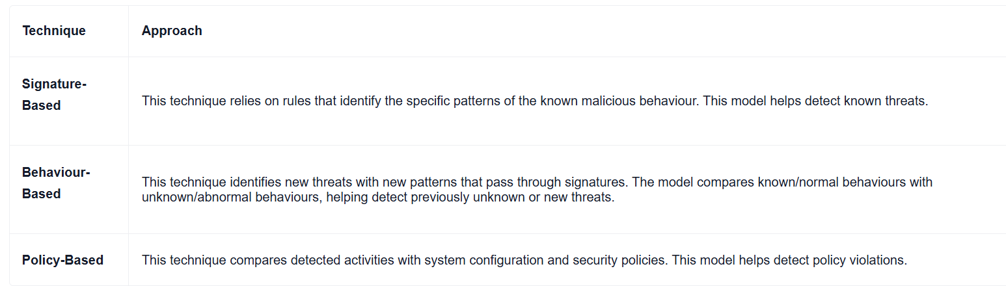

Summary

Let's summarise the overall functions of the IDS and IPS in a nutshell.

* IDS can identify threats but requires user assistance to stop them.
* IPS can identify and block threats with less user assistance at the time of detection.

**5. Snort Rule Structure and Syntax**

Snort’s power lies in its **rule-based detection**.  
Each rule defines **what traffic to watch for** and **what action to take** when that traffic is found.

**5.1 Rule Structure Overview**

A typical Snort rule has **two parts**:

1. **Rule Header** – Defines the action, protocol, IPs, and ports.
2. **Rule Options** – Describes the content and conditions.

**Example:**

alert tcp any any -> 192.168.1.0/24 80 (msg:"HTTP traffic detected"; content:"GET"; sid:1000001;)

**Breakdown:**

| **Component** | **Description** |
| --- | --- |
| alert | Action |
| tcp | Protocol |
| any any | Source IP and Port |
| -> | Direction of traffic |
| 192.168.1.0/24 80 | Destination IP and Port |
| (msg:"..."; content:"GET"; sid:1000001;) | Options |

**5.2 Rule Actions**

| **Action** | **Description** |
| --- | --- |
| alert | Generates alert and logs packet |
| log | Logs packet only |
| pass | Ignores packet |
| drop | Drops packet (IPS mode) |
| reject | Drops and sends reset message |
| sdrop | Silent drop (no alert) |

**5.3 Rule Options**

Rule options appear in parentheses and define specific criteria.

**Common Options:**

* msg – Custom alert message.
* content – String to search in payload.
* nocase – Case-insensitive search.
* sid – Snort rule ID.
* rev – Rule revision number.
* classtype – Type of attack (e.g., trojan-activity).

**Example:**



**5.4 Variables in Snort**

Variables make rules reusable.

**Defined in:** /etc/snort/snort.conf

**Example:**

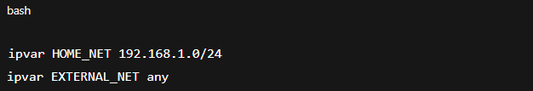

Then, in rules:

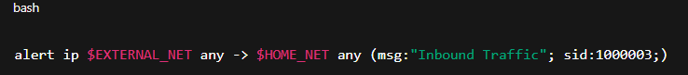

**5.5 Writing Custom Rules**

To create your own rule:

1. Add rule in /etc/snort/rules/local.rules.
2. Include it in snort.conf

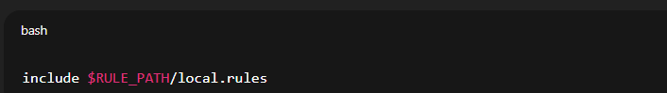

1. Restart Snort:

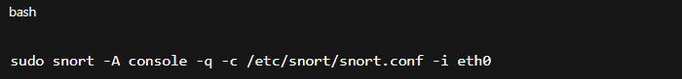

**Example:**

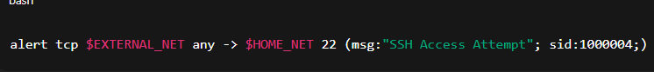

**6. Working of Snort**

Snort’s operation is built around a **pipeline-based architecture** that captures, analyzes, and classifies network packets in real time.  
It functions as both an **Intrusion Detection System (IDS)** and an **Intrusion Prevention System (IPS)** depending on how it’s configured.  
The entire working process revolves around **packet analysis**, **rule matching**, and **alerting**.

**6.1 Packet Flow in Snort**

The working of Snort can be visualized as a multi-stage process. Each stage transforms the network packet and passes it to the next layer for further inspection.

**Step-by-Step Packet Flow:**

1. **Packet Capture:**
   * Snort uses **libpcap** (on Linux) or **WinPcap/Npcap** (on Windows) to capture live packets from the network interface.
   * It can also read stored packet captures (.pcap files) for offline analysis.
2. **Packet Decoding:**
   * Decodes the data-link, network, and transport layer headers.
   * Extracts key information such as **source/destination IP**, **port numbers**, **protocol type**, and **flags**.
3. **Preprocessing:**
   * The **Preprocessor module** prepares data for analysis.
   * It normalizes and reconstructs fragmented packets or reassembled streams to ensure rules can properly analyze full payloads.
   * Common preprocessors include:
     + frag3 (handles fragmented IP packets)
     + stream5 (reassembles TCP sessions)
     + http_inspect (normalizes HTTP headers)
     + dns, telnet, smtp, etc.
4. **Detection Engine:**
   * This is the **core component** of Snort.
   * The detection engine compares the packet payload against **rule conditions**.
   * It checks for **specific keywords**, **regex patterns**, **IP addresses**, or **protocol behaviors**.
5. **Logging and Alerting:**
   * When a rule matches, Snort generates an **alert** or **log entry**.
   * Alerts contain:
     + Message (msg)
     + Rule ID (SID)
     + Source/Destination IP
     + Protocol and Port
     + Timestamp
6. **Output Module:**
   * Finally, alerts are sent to various outputs:
     + Console (stdout)
     + Log files
     + Databases (e.g., MySQL)
     + External systems (SIEMs, Security Onion, or Splunk)

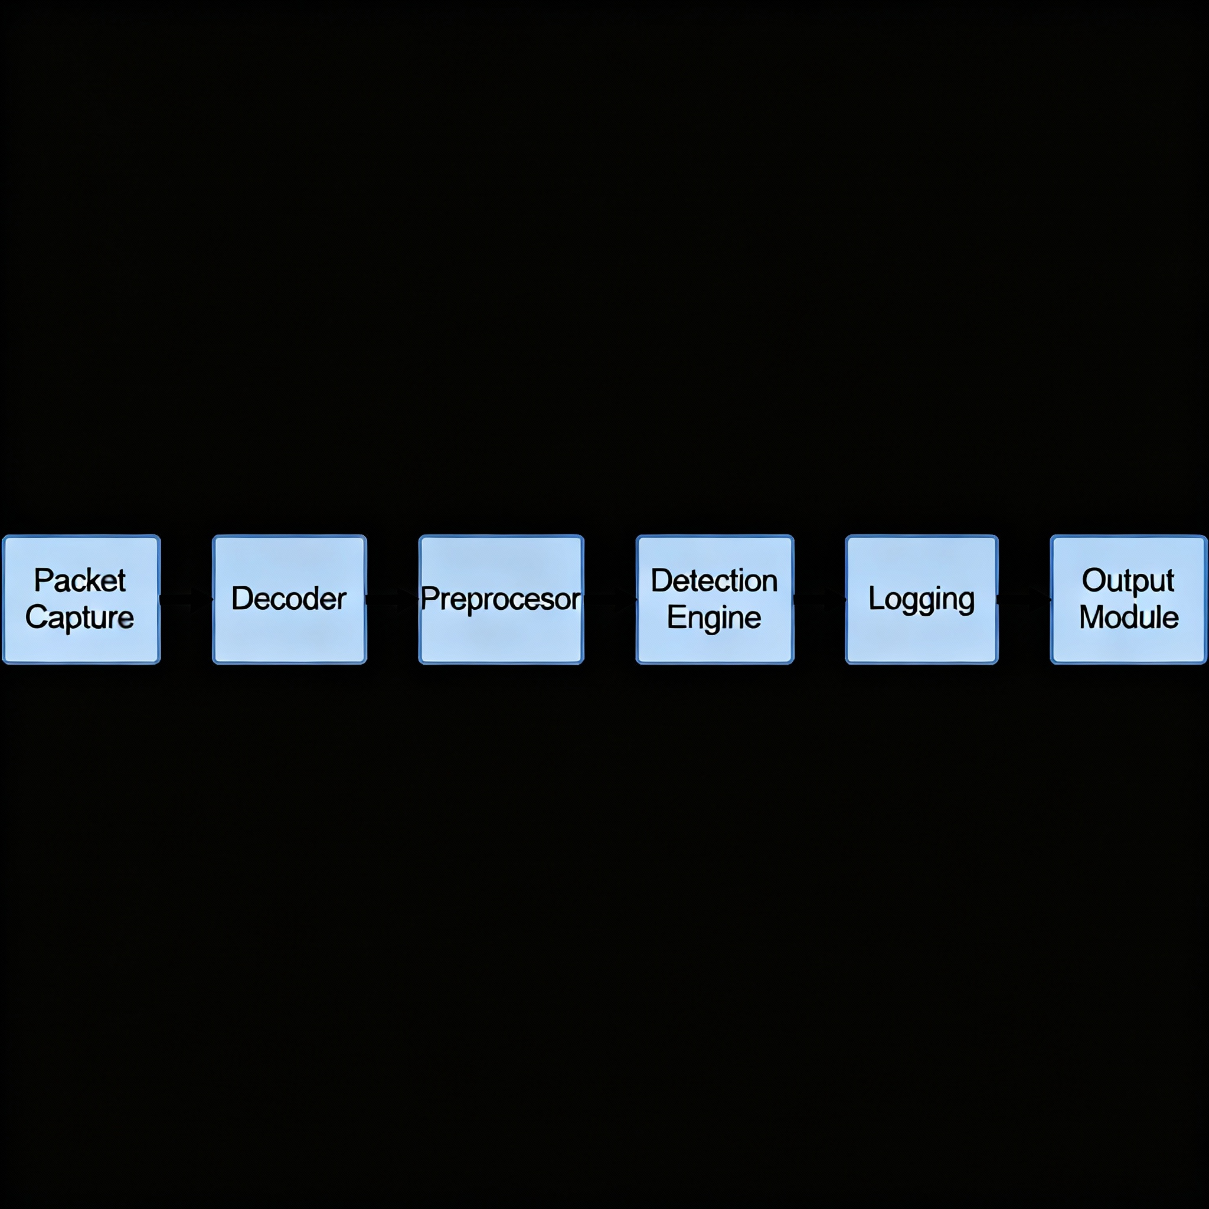

**6.2 Detection Process**

The **detection engine** is Snort’s “brain.” It decides whether network traffic is normal or malicious by checking if packets satisfy one or more rule conditions.

**1. Matching Stages**

Snort inspects each packet using multiple levels of analysis:

* **Header-based Matching:**  
  Examines IP/TCP/UDP headers for:
  + Source and destination addresses
  + Port numbers
  + Protocol type
  + Flags (e.g., SYN, ACK)
* **Content-based Matching:**  
  Inspects packet payload for specific **strings**, **byte sequences**, or **regular expressions**.  
  Example keywords:
  + content: — looks for exact strings.
  + pcre: — uses regex for complex patterns.
* **Behavioral Analysis:**  
  Detects anomalies or repeated malicious patterns (e.g., multiple failed login attempts, unusual DNS queries, or port scans).

**2. IDS vs IPS Behavior**

* **In IDS mode:**  
  Snort passively listens to network traffic, logs alerts, and does **not interfere** with packet flow.
* **In IPS mode:**  
  Snort actively **drops** or **rejects** malicious packets before they reach the target system.

**3. Alert Generation**

When a rule is triggered, Snort logs a message that looks like this:

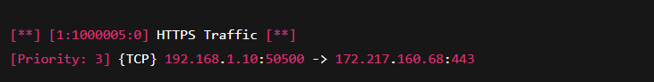

Each part of this message provides important context:

* **1:** Generator ID
* **1000005:** Signature ID (SID)
* **0:** Revision number
* **HTTPS Traffic:** Rule message
* **{TCP}:** Protocol
* **Source/Destination IP:** Indicates where the packet came from and where it was going

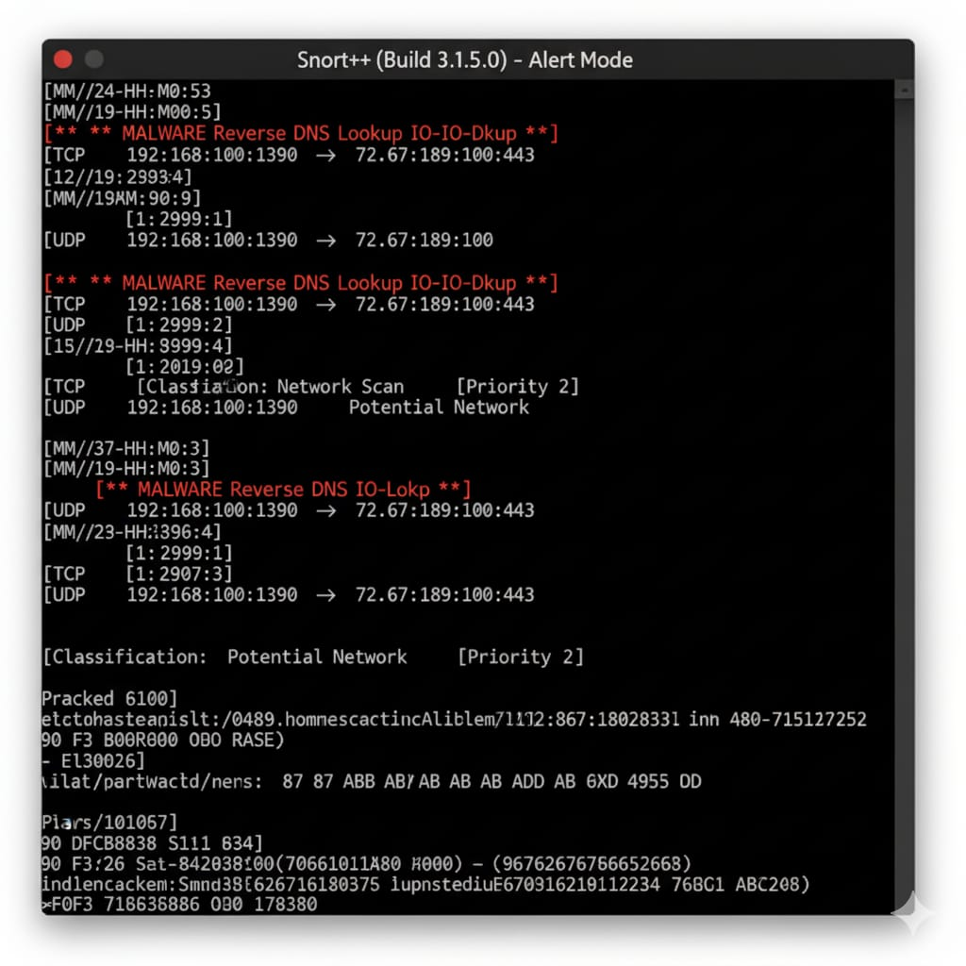

**6.3 Rule Matching Example**

Below is an example of a simple rule that detects HTTPS traffic:

alert tcp any any -> any 443 (msg:"HTTPS Traffic"; sid:1000005;)

**Explanation:**

| **Component** | **Description** |
| --- | --- |
| alert | Action to take when the rule matches (can be alert, log, drop, etc.) |
| tcp | Protocol to inspect |
| any any -> any 443 | Matches any source IP and port going to any destination IP on port 443 |
| msg:"HTTPS Traffic" | Message to display when the rule triggers |
| sid:1000005 | Unique Snort Rule ID |

**What happens:**

* When Snort detects a TCP packet destined for port 443 (HTTPS), it prints:
* [**] [1:1000005:0] HTTPS Traffic [**]
* [Priority: 3] {TCP} 192.168.1.5:60000 -> 142.250.182.142:443

**Advanced Example: Detecting Malicious Payload**

You can expand the rule to inspect the packet payload:

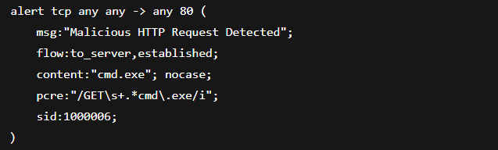**Explanation:**

* Flow : to_server,established — Checks only ongoing TCP sessions toward a server.
* Content : "cmd.exe" — Searches for the keyword cmd.exe (common in Windows exploitation).
* Pcre : "/GET\s+.*cmd\.exe/i" — Uses regex to detect any GET request containing cmd.exe.
* This rule detects **remote command execution attempts** in HTTP traffic.

**6.4 Logging and Alert Handling**

Once alerts are generated, Snort provides multiple ways to store or forward them:

* **Fast Alert Mode:** Outputs compact alerts to console or file.
* **Full Alert Mode:** Includes full packet details.
* **Unified2 Format:** Used by SIEM and visualization tools.
* **Syslog:** Sends alerts to system logs for integration with enterprise monitoring.

Example command:

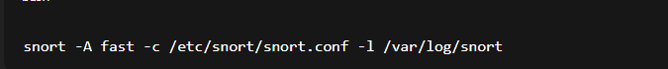

Snort logs each event with a timestamp, source/destination info, protocol, and triggered rule.

**7. Rule Management and Optimization**

**Efficient rule management is essential to ensure that Snort runs smoothly, detects new and emerging threats, and minimizes false positives.  
As networks evolve, so do attack techniques — therefore, keeping Snort’s rules updated and optimized is a continuous process.  
This section explains how Snort rules are maintained, updated, and tuned for performance.**

**7.1 Community and Registered Rule Sets**

**Snort rules are categorized into Community, Registered, and Subscriber rule sets.  
These collections are managed by Cisco Talos, which continuously updates them based on the latest threat intelligence.**

**Types of Rule Sets:**

| **Rule Type** | **Description** | **Access** |
| --- | --- | --- |
| **Community Rules** | **Open-source rules contributed by the Snort community. Provide basic protection and examples for beginners.** | **Free** |
| **Registered Rules** | **Updated by Cisco Talos; requires free registration. Offers more comprehensive coverage.** | **Free (registration required)** |
| **Subscriber Rules** | **Released earlier (30-day lead) and updated daily. Used by enterprises for proactive defense.** | **Paid subscription** |

**Best Practice:**

* **Combine Community and Registered rules for lab or learning environments.**
* **Use Subscriber Rules in production systems for timely detection.**
* **Regularly review rule changelogs to stay aware of new vulnerabilities and attack patterns.**

**7.2 Using PulledPork for Rule Updates**

**Manually updating Snort rules is inefficient.  
PulledPork is a powerful automation tool that simplifies downloading, managing, and applying Snort rule updates.**

**Key Features of PulledPork:**

* **Automatically fetches rules from Cisco Talos or custom repositories.**
* **Manages rule enable/disable lists.**
* **Compresses and organizes rules for Snort’s use.**
* **Supports multiple rule sources (Snort, Emerging Threats, custom rules).**

**Basic Usage:**

1. **Download PulledPork:**
2. **sudo apt install pulledpork**
3. **Configure rule paths in the config file:**
4. **/etc/pulledpork/pulledpork.conf**

**Add your oinkcode (from Snort.org) to download registered or subscriber rules.**

1. **Update Rules:**
2. **sudo pulledpork.pl -c /etc/pulledpork/pulledpork.conf -l**
3. **Restart Snort:**
4. **sudo systemctl restart snort**

**PulledPork ensures that your Snort engine always runs with the latest signatures and removes deprecated or outdated rules automatically.**

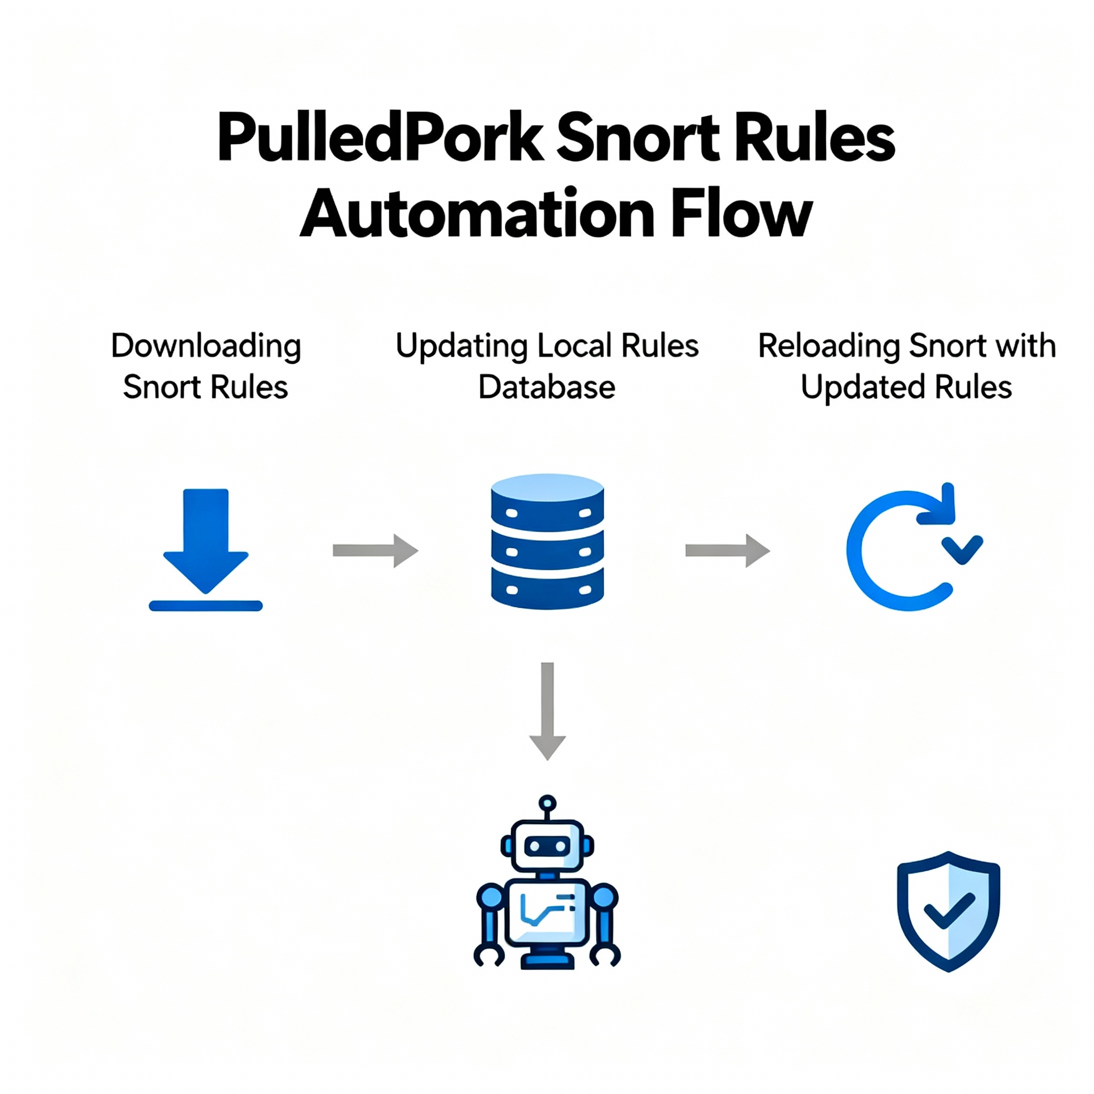

**7.3 Rule Prioritization and Performance Tuning**

**As Snort deployments scale up, performance tuning becomes critical to avoid packet loss and alert floods.  
Rule prioritization helps analysts focus on critical alerts first and ensures optimal CPU and memory usage.**

**Optimization Techniques:**

1. **Disable Unused Rules:  
   Comment out or disable signatures irrelevant to your environment.  
   Example: If you don’t run web servers, disable HTTP-related rules.**
2. **Use Fast Pattern Matching:  
   Snort’s detection engine uses fast pattern matching algorithms (like Aho-Corasick).  
   Optimize your rules by keeping shorter, unique patterns in the content field.**
3. **Adjust Rule Priorities:  
   Each Snort rule can include a priority level:**



* + **Priority 1: High severity (exploits, malware)**
  + **Priority 2: Medium (scans, reconnaissance)**
  + **Priority 3: Informational (normal traffic indicators)**

1. **Enable Stream Preprocessors:  
   Preprocessors help normalize fragmented packets before analysis, improving detection accuracy.**
2. **Leverage Multithreading (Snort 3):  
   Snort 3 introduces multithreaded packet processing, allowing better CPU utilization on modern systems.**

**Performance Metrics to Monitor:**

* **Packet Drop Rate**
* **CPU and Memory Usage**
* **Detection Latency**
* **False Positive/Negative Ratios**

**7.4 Signature vs. Anomaly-Based Detection**

**Snort primarily uses signature-based detection, but understanding the contrast with anomaly-based systems helps optimize rule creation.**

| **Feature** | **Signature-Based** | **Anomaly-Based** |
| --- | --- | --- |
| **Basis** | **Matches known patterns or rules** | **Detects deviations from normal behavior** |
| **Accuracy** | **High (for known threats)** | **Detects unknown/zero-day threats** |
| **False Positives** | **Low (for tuned rules)** | **Higher if baseline not accurate** |
| **Performance** | **Faster (rule-based)** | **Slower (requires statistical analysis)** |
| **Example Tools** | **Snort, Suricata** | **Zeek (Bro), AI-based IDS** |

**How Snort Combines Both:**

* **Signatures handle known threats (e.g., SQLi, malware traffic).**
* **Anomaly detection preprocessors (in Snort 3 and Security Onion) can identify unknown or behavioral deviations.**
* **Integration with machine learning models enhances detection by correlating Snort alerts with behavioral anomalies.**

**7.5 Summary**

**Efficient rule management ensures that Snort remains accurate, fast, and up-to-date.  
By combining automated rule updates (PulledPork), prioritization, and performance tuning, administrators can maintain a balance between detection depth and system efficiency.**

**Snort’s modular design and strong rule community make it one of the most flexible and scalable network security tools available today.**

**8. Integration with Other Security Tools**

**Snort is most effective when integrated into a larger cyber defense ecosystem.  
By combining Snort with SIEMs, firewalls, forensic frameworks, and centralized log management, organizations gain real-time visibility, automated alerting, and better incident response capabilities.**

**This section explores how Snort connects with other tools to create a unified threat-detection environment.**

**8.1 Snort with SIEM (Splunk, ELK Stack)**

**Security Information and Event Management (SIEM) platforms such as Splunk and ELK Stack (Elasticsearch, Logstash, Kibana) are used to aggregate and visualize alerts from multiple sources — including Snort.**

**Integration Workflow:**

1. **Snort generates alerts (alert_fast, alert_full, or unified2 formats).**
2. **Logstash or Splunk’s Universal Forwarder collects Snort logs.**
3. **The data is parsed, indexed, and visualized in dashboards.**
4. **Analysts investigate alerts, correlate with other logs (firewall, system, application), and take actions.**

**Benefits:**

* **Centralized visibility of Snort alerts.**
* **Correlation with endpoint, DNS, and proxy data.**
* **Trend analysis and custom dashboards.**
* **Real-time threat hunting and automated response.**

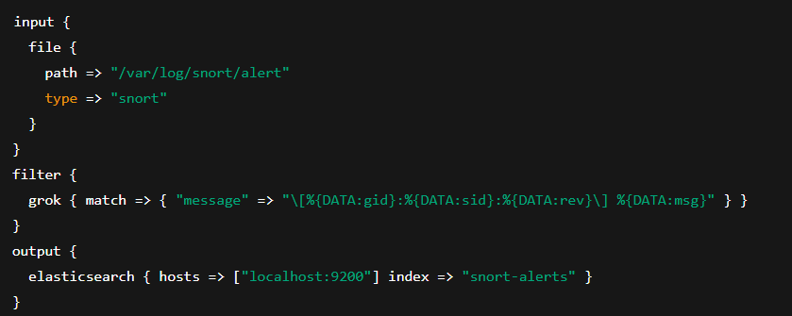

**8.2 Snort with Security Onion**

**Security Onion is a Linux distribution built for network security monitoring, which includes Snort (or Suricata) as one of its core IDS components.**

**Key Features:**

* **Pre-configured environment with Snort, Zeek, Wazuh, Elasticsearch, Kibana, and OSSEC.**
* **Provides dashboards for intrusion detection, host monitoring, and packet capture.**
* **Automates alert correlation between different sensors.**

**Integration Benefits:**

* **Simplified deployment of Snort in enterprise environments.**
* **Correlated alerts with Zeek logs for deep packet analysis.**
* **Scalable architecture — multiple Snort sensors feeding a single dashboard.**

**Typical Workflow:**

1. **Security Onion sensors capture and mirror traffic.**
2. **Snort analyzes traffic based on Talos or custom rule sets.**
3. **Alerts are stored and visualized in the built-in Kibana dashboards.**
4. **Analysts can pivot from Snort alert → PCAP → session details in one interface.**

**8.3 Snort with Firewalls and IPS Systems**

**When configured in Inline (IPS) mode, Snort can directly interact with network firewalls and intrusion prevention systems to block malicious packets in real time.**

**Integration Scenarios:**

1. **Snort + iptables:**
   * **Snort detects malicious traffic and triggers an action (drop/reject) using NFQUEUE.**
   * **Example setup:**

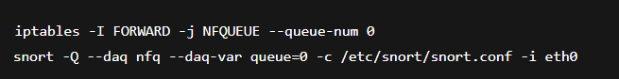

1. **Snort with pfSense:**
   * **pfSense offers a GUI plugin for Snort integration.**
   * **Allows administrators to enable/disable rules, view alerts, and block IPs automatically.**
2. **Snort + Cisco Firepower:**
   * **Cisco Firepower Threat Defense uses Snort 3 engine for deep packet inspection and automated IPS capabilities.**

**Advantages:**

* **Real-time packet blocking (prevention, not just detection).**
* **Seamless policy enforcement with network firewalls.**
* **Reduced response time to active threats.**

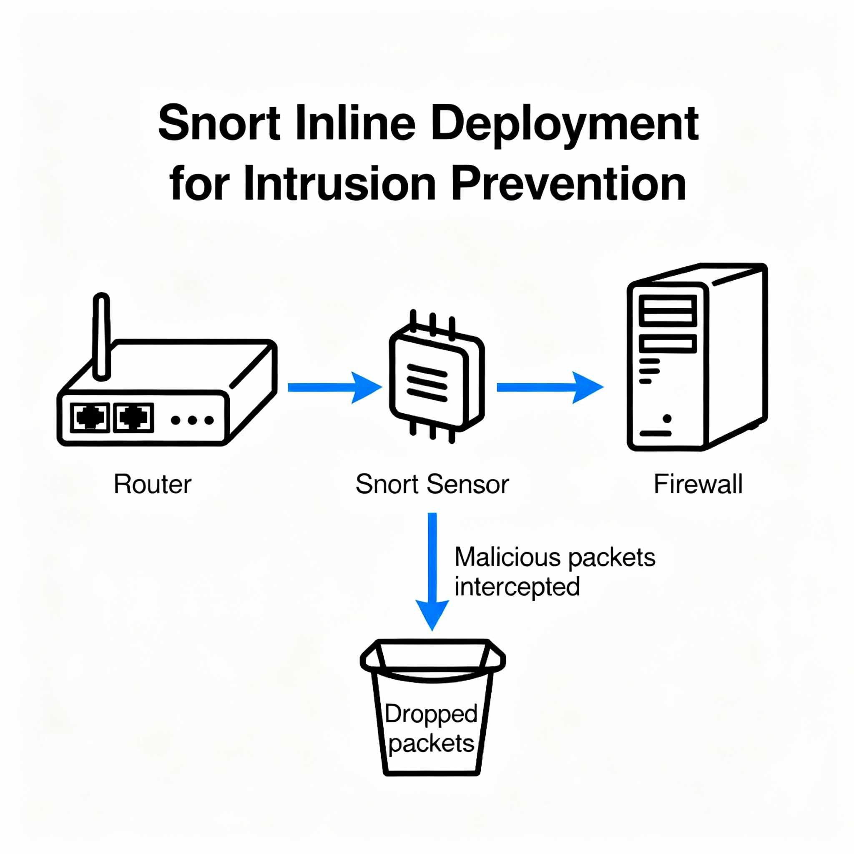

**8.4 Logging with Syslog / MySQL**

**Centralized logging is crucial for large deployments. Snort can forward its alerts to Syslog servers or MySQL databases for long-term storage and analysis.**

**Syslog Integration:**

**Snort can log directly to /var/log/syslog or to a remote syslog server.**



**This enables integration with log-management tools like Graylog or SIEMonster.**

**MySQL Logging:**

**Snort supports database logging (mostly for legacy setups or research).**



**Benefits:**

* **Structured storage of alerts (time, source, destination, signature).**
* **Easier querying and data correlation using SQL.**
* **Compatible with web interfaces such as BASE (Basic Analysis and Security Engine) or Snorby.**

**Modern Alternative:**

**Today, JSON or Unified2 formats are preferred for exporting Snort logs to advanced analysis tools instead of direct database writes.**

**9. Case Study: Snort in Action**

**To understand the real-world impact of Snort, it is essential to explore how it functions in active network environments.  
The following case studies illustrate Snort’s role in detecting port scans, Denial of Service (DoS) attacks, malware traffic, and its deployment in an enterprise setting.**

**These examples demonstrate Snort’s flexibility, effectiveness, and adaptability in both research and operational security infrastructures.**

**9.1 Detecting Port Scans and DoS Attacks**

**Port scanning is a common reconnaissance technique attackers use to identify open services before launching further attacks. Snort’s rule-based detection engine can easily identify such suspicious patterns and raise alerts in real time.**

**Scenario:**

**A network administrator deploys Snort on the gateway interface monitoring all incoming and outgoing traffic. During peak hours, multiple alerts indicate rapid connection attempts from a single IP to different ports on a target server.**

**Snort Rule Example (Port Scan Detection):**

**alert tcp any any -> $HOME_NET any (msg:"Potential Port Scan Detected"; flags:S; threshold:type both, track by_src, count 20, seconds 3; sid:1000001; rev:1;)**

**Detection Process:**

1. **Snort observes multiple SYN packets from a single IP within a short duration.**
2. **The threshold rule triggers an alert once the connection attempts exceed a predefined limit.**
3. **The alert message includes source IP, timestamp, and targeted ports.**

**Result:**

* **Snort successfully detects and logs the scanning activity.**
* **The administrator blocks the attacker’s IP via firewall integration.**
* **Follow-up correlation in a SIEM system confirms no internal compromise occurred.**

**DoS Attack Detection Example:**

**For detecting DoS or DDoS traffic (e.g., ICMP floods):**

**alert icmp any any -> $HOME_NET any (msg:"ICMP Flood Detected"; threshold:type both, track by_src, count 100, seconds 1; sid:1000002; rev:1;)**

**Outcome:**

* **The rule detects excessive ICMP packets, indicating a possible flood attack.**
* **Automated blocking or rate-limiting prevents network congestion.**

**9.2 Malware Traffic Detection**

**Snort is widely used to identify malicious payloads, C2 communications, and malware download attempts by matching known signatures within packet content.**

**Scenario:**

**A user unknowingly downloads a suspicious file from a phishing email. The infected system begins communicating with a known malicious domain.**

**Snort Rule Example (Malware C2 Detection):**

**alert tcp any any -> any 80 (msg:"Malware C2 Communication Detected"; content:"malicious-domain.com"; http_host; sid:1000003; rev:1;)**

**Detection Process:**

1. **Snort inspects outgoing HTTP packets from internal hosts.**
2. **When the Host header matches the known C2 domain, Snort triggers an alert.**
3. **Logs are forwarded to the SIEM for correlation with other endpoint indicators.**

**Analysis and Response:**

* **The alert reveals the infected host’s IP and timestamp.**
* **Security team isolates the host and performs malware removal.**
* **A YARA rule (at the endpoint level) later confirms the same binary signature, showing how Snort and YARA complement each other.**

**Impact:**

* **Early detection of network-based malware behavior.**
* **Prevented data exfiltration and lateral movement within the internal network.**

**9.3 Example Enterprise Deployment**

**Large enterprises use Snort as part of a multi-layered intrusion detection and prevention architecture. Below is a realistic case study of a Snort deployment in a corporate environment.**

**Organization Overview:**

* **Industry: Financial Services**
* **Network Size: 1,500 endpoints, multiple branch offices**
* **Security Tools: Snort, Splunk (SIEM), pfSense, and Security Onion**

**Architecture:**

1. **Snort Sensors deployed at network entry and exit points.**
2. **Inline Mode used at data centers for blocking malicious traffic.**
3. **Passive Mode used at branch offices for detection and analysis.**
4. **All Snort logs are forwarded to Splunk via Syslog for centralized correlation.**
5. **Alerts are visualized in Security Onion dashboards for quick triage.**

**Workflow Example:**

1. **A spike in outbound traffic is detected by Snort’s anomaly rules.**
2. **Splunk correlates this with failed login attempts and DNS anomalies.**
3. **The SOC team investigates and confirms brute-force activity followed by data exfiltration attempts.**
4. **Snort automatically blocks the IP using inline firewall rules.**

**Key Benefits Observed:**

* **Detection Efficiency: Snort identified threats missed by antivirus tools.**
* **Cost-Effective: Open-source deployment reduced licensing costs.**
* **Scalability: Integration with Security Onion and Splunk enabled monitoring across multiple sites.**
* **Proactive Defense: Inline blocking stopped attacks before they caused major damage.**

**10. Advantages and Limitations of Snort**

**Snort’s popularity as one of the world’s leading open-source intrusion detection and prevention systems stems from its flexibility, strong community support, and real-time detection capabilities.  
However, like any tool, it also has certain limitations that must be understood to ensure effective deployment and maintenance.**

**10.1 Advantages of Snort**

**Snort offers several strengths that make it suitable for organizations of all sizes — from small businesses to large enterprises.**

**1. Open Source and Cost-Effective**

* **Snort is completely free and open source, which allows organizations to deploy and customize it without expensive licensing fees.**
* **Supported by Cisco Talos, Snort benefits from a vast community that regularly contributes new rules, signatures, and threat intelligence.**
* **Its accessibility makes it an excellent option for research labs, academic use, and SOC training environments.**

**2. Highly Flexible and Customizable**

* **Snort rules are human-readable, allowing analysts to write, modify, and fine-tune detection logic according to their needs.**
* **Users can detect specific attack patterns, suspicious payloads, or even organization-specific policies.**
* **Modular architecture supports plugins and preprocessors for extended functionality such as packet normalization, decoding, and anomaly detection.**

**3. Real-Time Intrusion Detection and Prevention**

* **Snort works both as a Network Intrusion Detection System (NIDS) and Network Intrusion Prevention System (NIPS).**
* **It can:**
  + **Capture and analyze live traffic using libpcap.**
  + **Generate alerts when patterns match known attack signatures.**
  + **Operate in inline mode to block malicious packets in real-time.**
* **This enables proactive network defense before an attacker can exploit vulnerabilities.**

**4. Large Community and Rule Database**

* **Thousands of community-contributed rules are available through Snort’s Registered and Community rule sets.**
* **Integration with PulledPork or Snort Rule Updater automates fetching and updating signatures.**
* **The global community also provides documentation, tutorials, and case studies — reducing the learning curve for beginners.**

**5. Integration Capabilities**

* **Snort easily integrates with SIEM tools (like Splunk, ELK Stack), Security Onion, firewalls, and network monitoring systems.**
* **Log data can be stored in MySQL, syslog, or JSON formats, enabling rich analytics and visualization.**
* **Combined with other tools, Snort becomes a part of a comprehensive security monitoring ecosystem.**

**6. Educational and Research Value**

* **Snort’s transparency and simplicity make it ideal for learning packet analysis, intrusion detection logic, and network forensics.**
* **Many cybersecurity training labs, such as TryHackMe, RangeForce, and CyberDefenders, use Snort for hands-on exercises.**

**10.2 Limitations of Snort**

**While Snort is a powerful IDS/IPS, it is not without its challenges. Understanding its constraints is essential for realistic deployment expectations.**

**1. Performance and Scalability**

* **Snort can experience performance degradation in high-speed or large-scale network environments (e.g., 10 Gbps+ links).**
* **Heavy rule sets or complex regex-based detections can cause packet drops if not optimized.**
* **Requires careful hardware tuning and multi-threaded optimization (especially in Snort 2.x).**

**Improvement:  
Snort 3 introduces multi-threading, packet batching, and modular configuration, significantly improving performance on modern hardware.**

**2. Difficulty in Managing Large Rule Sets**

* **Managing thousands of rules manually can be complex and prone to misconfiguration.**
* **Frequent updates are required to maintain detection accuracy against new threats.**
* **Overlapping or redundant rules can cause false positives and impact processing speed.**

**Solution:  
Tools like PulledPork automate rule management and ensure efficient prioritization.**

**3. Encrypted Traffic Limitation**

* **Snort cannot inspect the payload of encrypted packets (HTTPS, SSH, TLS) directly.**
* **This means malicious activity within encrypted sessions may go undetected.**
* **Decryption or SSL/TLS termination must occur before Snort (e.g., via proxy) for visibility.**

**Mitigation:  
Use Snort in conjunction with SSL inspection proxies or endpoint detection tools to fill this visibility gap.**

**4. False Positives and Tuning Overhead**

* **Signature-based detection can result in false positives when benign traffic matches known patterns.**
* **Requires continuous tuning and contextual analysis to avoid alert fatigue.**
* **SOC teams often integrate Snort alerts with SIEM correlation to reduce noise.**

**Best Practice:  
Regularly review alerts, whitelist known benign patterns, and prioritize based on severity and asset criticality.**

**5. Limited Behavioral or AI-Based Detection**

* **Snort primarily relies on signature-based or rule-based detection.**
* **It may not identify zero-day attacks or novel malware without prior signatures.**
* **Modern threats use polymorphism and encryption, evading traditional rules.**
* **Mitigation:  
  Combine Snort with machine learning models, YARA rules, or threat intelligence feeds for hybrid detection capabilities.**

**11. Comparison with Other NIDS/NIPS Tools**

**Snort is widely recognized as a pioneer in intrusion detection systems. However, other modern tools such as Suricata and Zeek (formerly Bro) have gained significant popularity in recent years.  
Each has its unique strengths, architecture, and use cases — understanding these differences helps organizations choose the right tool for their network security environment.**

**11.1 Snort vs Suricata**

**Both Snort and Suricata are signature-based NIDS/NIPS tools, but they differ in performance architecture, language support, and scalability.**

**Overview**

| **Feature** | **Snort** | **Suricata** |
| --- | --- | --- |
| Developer | Cisco Talos | Open Information Security Foundation (OISF) |
| Language | C / C++ (Snort 3) | C |
| Detection Type | Signature-based | Signature + Protocol + Anomaly Detection |
| Multithreading | Introduced in Snort 3 | Native since inception |
| Packet Capture | Libpcap / DAQ | Libpcap / AF-Packet / PF-Ring / Netmap |
| Rule Compatibility | Compatible with Snort rules | Largely Snort-rule compatible |
| Performance | High (with tuning) | Excellent for multi-core systems |
| Best Use Case | Lightweight or research deployments | High-performance enterprise monitoring |

**Key Comparisons**

1. **Performance and Scalability**
   * ***Suricata* was built with multi-threading from the start, efficiently utilizing all CPU cores.**
   * ***Snort 2* was single-threaded; *Snort 3* introduced multithreading to close the gap.**
   * **In high-speed networks (10–40 Gbps), Suricata often handles more traffic with less packet loss.**
2. **Protocol Awareness**
   * **Suricata performs deep protocol parsing (HTTP, TLS, DNS, SMB, etc.) natively.**
   * **Snort relies on preprocessors for protocol decoding; this modular approach allows flexibility but may increase complexity.**
3. **Logging and Output**
   * **Suricata supports JSON output natively for easy integration with ELK (Elasticsearch, Logstash, Kibana) stacks.**
   * **Snort supports text, unified2, or syslog formats — ELK integration requires conversion or plugins.**
4. **Rule Compatibility and Updates**
   * **Both tools can use Emerging Threats (ET) and Snort community rule sets.**
   * **Suricata adds extended keywords and variables not present in Snort.**
5. **Performance Tuning**
   * **Snort requires careful manual tuning (e.g., rule pruning, DAQ configuration).**
   * **Suricata dynamically balances load across threads, simplifying optimization.**

**When to Choose Which**

* **Choose Snort for:**
  + **Stability and proven enterprise support (Cisco Talos).**
  + **Training, research, or lightweight deployments.**
* **Choose Suricata for:**
  + **High-speed enterprise networks.**
  + **Environments needing JSON logging, protocol detection, or multithreading out of the box.**

**11.2 Snort vs Zeek**

**While Snort and Suricata focus on signature-based detection, Zeek (formerly Bro) takes a behavioral and event-driven approach to network monitoring.**

**Overview**

| **Feature** | **Snort** | **Zeek (Bro)** |
| --- | --- | --- |
| Detection Type | Signature-based | Behavioral & Policy-based |
| Developer | Cisco Talos | Zeek Project / ICSI |
| Primary Function | Intrusion detection/prevention | Network analysis & forensics |
| Language | C / C++ (Snort 3) | C++ + Zeek scripting language |
| Performance Model | Packet-based | Event-driven |
| Output Format | Alerts / logs | Detailed event logs |
| **Best Use Case** | **Real-time blocking and alerting** | **Deep network visibility and investigation** |

**Key Comparisons**

1. **Detection Approach**
   * ***Snort* matches packets against known attack signatures — ideal for known threats.**
   * ***Zeek* focuses on network behavior and anomalies, making it strong in unknown or new attack detection.**
2. **Customization and Scripting**
   * ***Snort rules* are static and primarily text-based.**
   * ***Zeek* includes a powerful scripting language to define policies, track sessions, or trigger complex detection logic.**
   * **Analysts can write scripts to detect protocol deviations, data exfiltration, or policy violations.**
3. **Use Case Focus**
   * ***Snort*: Detect and optionally block malicious traffic in real time (NIDS/NIPS).**
   * ***Zeek*: Record and analyze all network activities for later inspection — acts as a Network Security Monitor (NSM).**
4. **Integration**
   * **Zeek integrates tightly with Security Onion, ELK, and threat-hunting tools.**
   * **Snort integrates with SIEMs for alert correlation and incident response.**
5. **Output and Logging**
   * **Zeek produces rich, structured logs (HTTP, DNS, SSL, SMTP, etc.) that are valuable for forensic analysis.**
   * **Snort provides concise alerts that are more suitable for immediate detection and prevention.**

**12. Conclusion and Future Scope**

**Snort has evolved from a simple packet sniffer into one of the most powerful, versatile, and trusted intrusion detection and prevention systems (IDS/IPS) in the cybersecurity ecosystem.  
Through continuous innovation, community involvement, and Cisco’s backing, Snort remains a critical tool for network defenders, SOC analysts, and cybersecurity researchers worldwide.**

**As cyber threats become increasingly complex, Snort’s journey — particularly with Snort 3.x — showcases how open-source tools can adapt to meet the evolving demands of enterprise security.**

**12.1 The Evolution to Snort 3.x**

**Snort 3 represents a complete architectural redesign from the earlier Snort 2.x versions, introducing modularity, scalability, and flexibility for modern network environments.**

**Key Enhancements in Snort 3**

1. **Modular Architecture**
   * **Snort 3 is built as a modular framework, allowing dynamic loading and configuration of components such as decoders, preprocessors, and output modules.**
   * **Analysts can customize pipelines according to deployment needs, improving performance and maintainability.**
2. **Performance Improvements**
   * **Snort 3 introduces multi-threading and packet batching, enabling efficient utilization of multi-core processors.**
   * **Reduced packet drops, faster throughput, and optimized memory usage make it more suitable for high-speed enterprise networks.**
3. **Unified Configuration**
   * **Unlike Snort 2, which relied on multiple files (snort.conf, classification.config, etc.), Snort 3 uses a Lua-based configuration system.**
   * **Lua scripting allows greater flexibility for dynamic configurations, conditional logic, and automation.**
4. **Improved Detection Capabilities**
   * **Enhanced rule syntax with extended keywords for precision matching.**
   * **AppID and service detection allow for smarter traffic analysis across protocols.**
   * **Integration with Cisco Talos rule updates ensures cutting-edge signature coverage against emerging threats.**
5. **Better Integration and Extensibility**
   * **Snort 3 provides native support for JSON outputs, making it easier to integrate with SIEMs, ELK Stack, and orchestration tools.**
   * **Plugin-based approach supports easy extension for new detection technologies and third-party integrations.**
6. **Ease of Deployment**
   * **Snort 3 supports containerized deployment using Docker or Kubernetes, enabling scalable, cloud-ready security operations.**
   * **Cross-platform compatibility across Linux, Windows, and BSD environments remains strong.**

**Snort 2 vs Snort 3 Snapshot**

| **Feature** | **Snort 2.x** | **Snort 3.x** |
| --- | --- | --- |
| **Architecture** | **Monolithic** | **Modular** |
| **Configuration** | **Static (conf files)** | **Dynamic (Lua scripting)** |
| **Performance** | **Single-threaded** | **Multi-threaded** |
| **Integration** | **Limited** | **Cloud/SIEM-ready** |
| **Ease of Customization** | **Moderate** | **High** |
| **Detection Logic** | **Signature-based** | **Signature + Application-aware** |

**12.2 Role of Snort in Modern SOC Pipelines**

**In the age of cloud computing, zero trust, and AI-driven cyber defense, Snort continues to hold a strategic position in Security Operations Centers (SOCs) around the world.**

**1. Integration with SOC Tools**

* **Snort integrates seamlessly with SIEM platforms such as Splunk, ELK Stack, and QRadar, feeding real-time alerts for correlation and threat analysis.**
* **In Security Onion distributions, Snort works alongside Zeek, Suricata, and Wazuh, forming a layered detection ecosystem.**

**2. Role in Incident Detection and Response**

* **Snort alerts help SOC analysts identify potential compromises, port scans, or malware communications.**
* **When combined with automated response systems (SOAR), Snort can trigger containment actions such as:**
  + **Blocking malicious IPs.**
  + **Isolating infected hosts.**
  + **Alerting analysts for investigation.**

**3. Complementing Threat Intelligence**

* **Integration with Cisco Talos and Emerging Threats feeds ensures that Snort always operates with up-to-date threat intelligence.**
* **Analysts can also build custom rules tailored to organization-specific attacks or IoCs (Indicators of Compromise).**

**4. AI, ML, and Behavioral Analytics**

* **Although Snort itself is signature-based, it can be combined with machine learning frameworks to detect zero-day attacks and anomalies.**
* **Example pipeline:**
  + **Snort captures suspicious packets.**
  + **Data forwarded to ML-based anomaly detection engine.**
  + **Alerts enriched with behavioral scores and contextual threat data.**

**5. Cloud and Hybrid Deployments**

* **Snort 3’s lightweight and modular design makes it suitable for cloud-native deployments.**
* **Can operate as:**
  + **A containerized IDS within Kubernetes clusters.**
  + **A sensor node within distributed security infrastructures.**

**6. Contribution to Defense-in-Depth Strategy**

* **In modern SOC pipelines, Snort plays a frontline detection role:**
  + **Snort detects and prevents intrusions in real-time.**
  + **Zeek provides deep visibility and context.**
  + **SIEMs correlate alerts and support response automation.**
  + **Together, they form a holistic network defense mechanism.**

**12.3 Future Outlook**

**As cyber threats evolve, Snort’s future lies in intelligent automation, cloud adaptation, and AI-driven detection.  
The combination of open-source transparency and Cisco’s enterprise support ensures its continued relevance in the cybersecurity landscape.**

**Key future directions:**

* **Deeper AI/ML integration for behavioral detection.**
* **Enhanced cloud-native support for AWS, Azure, and GCP.**
* **Faster rule compilation and distributed detection.**
* **Improved TLS/SSL inspection to counter encrypted threats.**
* **Collaboration with other open-source tools for unified threat management.**

**Snort 3.x marks the beginning of a new era of intelligent intrusion detection, bridging traditional signature-based defense with modern adaptive security.**

**12.4 Final Thoughts**

**Snort’s evolution showcases how open-source innovation and community collaboration can rival commercial security solutions.  
Its scalability, adaptability, and reliability make it an essential pillar in defending networks against modern threats.  
With Snort 3 paving the way for next-generation intrusion detection, Snort continues to empower cybersecurity professionals with visibility, control, and proactive defense capabilities.**

**13. References**

* **Snort Rule Writing Guide:  
  Covers syntax and best practices for creating custom detection rules.**
* **TryHackMe:  
  Practical labs and walkthroughs for hands-on learning in intrusion detection and network security.**